## ONESYS: ENHANCEMENT AND DEPLOYMENT OF BARANGAY MANAGEMENT

**INFORMATION SYSTEM IN THE BAYANI CLUSTER**

A Title Research Proposal

Submitted to the Faculty of the

Department of Information Technology

Cavite State University Silang, Cavite

In partial fulfillment of the requirements for the Capstone

**ESPIRITU, DAVE P. JOSE, ARIANNE Q.**

**LANZONA, LOUBRIX KELLY C.**

**LAZARO, NIEJHAY C.**

**NAQUILA, KENNETH V.**

**PANTI, RUEL G.**

MAY 16

## TABLE OF CONTENTS

**INTRODUCTION**  2

Project Context 5

Objectives of the Study 7

Purpose and Description 8

Scope and Limitation of the Study 9

Time and Place of the Study 10

Conceptual Framework 11

Definition of Terms 12

**REVIEW OF RELATED LITERATURE**  15

Related Literature/ Related Studies 15

System Technical Background 24

Synthesis 25

**METHODOLOGY**  26

Planning 34

Requirement Analysis

Designing 34

Building 35

Testing 35

System Evaluation 35

**REFERENCES**  90

## TABLE OF TABLES

**Table**  **Page**

1 List of technical resources uses to run the project to be developed 32

2 Descriptive interpretations of the mean 36

3 Implementation plan 37

4 First testing for environments of the system 60

5 Second testing for environments of the system 61

6 Software test environment results under functionality criteria 62

7 Overall results of functionality of the system 67

8 Portability Testing for 72

9 Functional suitability evaluation 73

10 Performance efficiency evaluation 74

11 Compatibility evaluation 75

12 Usability evaluation 76

13 Reliability evaluation 77

14 Security evaluation 79

15 Maintainability evaluation 80

16 Portability evaluation 81

17 Overall evaluation result 82

18 Summary of implementation results 83

## TABLE OF FIGURES

**Figure Page**

1 Conceptual Framework of the study 11

2 hierarchical input-process-output diagram 27

3Flowchart diagram 28

4 Barangay view and add household 29

5 Use case Diagram 30

6 Graphical user interface design of the Bayani Onesys 30

7 Fishbone Diagram of the Operational Feasibility of Bayani Onesys 32

8 Dashboard 38

9 View All Household 39

10 Add Household 40

11 View all resident 41

12 Add resident 42

13 Analytics 42

14 Transaction history 43

15 Create New certificates 44

16 View all certificates 45

17 Certificate layout 45

18 Add user accounts 46

19 View all accounts 47

20 View all deleted accounts 47

21 Barangay account log 48

22 Session Logs 49

23 Barangay Settings 49

24 Visual Studio Code 50

25 HTML & CSS designs 51

26 Laravel 52

27 PHP 52

28 Sample source code from Laravel to Firebase 53

29 Sample source code in Firebase (FRD) 53

**ABSTRACT**

**ESPIRITU, DAVE P., JOSE, ARIANNE Q., LAZARO, NIEJHAY C., LANZONA, LOUBRIX KELLY C., NAQUILA, KENNETH V., PANTI, RUEL G.**

**Onesys: Enhancement and Development of Barangay Management Information System in the Bayani Cluster.** Undergraduate Capstone Project. Bachelor of Science in Information Technology. Cavite State University, Silang Campus, Silang, Cavite. September 2025. Adviser: Mr. Cereneo S. Santiago Jr.

The study was conducted from April 2024 to December 2025 in Barangay Bulihan, Silang, Cavite, to develop a Onesys Enhancement and Development of Barangay Management Information System in the Bayani Cluster. Specifically, it aimed to: (1) design and enhance the bayani Onesys with the following additional features such as blotter report management, business permit processing and payment transaction monitoring; (2) develop and enhance the bayani onesys using Laravel, Bootstrap, for functionality and a responsive design, SQL for secure and efficient database management and Visual Studio Code IDE was utilized as code editor; (3) test the system using unit, integration, and system testing; (4) evaluate the system’s quality using the ISO 25010 evaluation framework; and (5) prepare an implementation plan.

The researchers used the Agile model to develop the system to ensure iterative development and stakeholder feedback integration. The performance of the system was evaluated by thirty (30) end user, and ten (10) IT Experts. Comprehensive evaluations yielded an overall mean rating of 4.92, interpreted as " Highly Acceptable," with individual aspects such as usability, security, and functionality receiving "Excellent" ratings.

The Bayani Onesys system enhanced barangay operations by streamlining record management, increasing overall efficiency, and ensuring data security. This enhanced platform simplifies the process of issuing documents issuance, makes it easier to track transactions, handles blotter reports more effectively, and speeds up the processing of business permits, enabling for faster and more reliable services.

## ONESYS: ENHANCEMENT AND DEPLOYMENT OF BARANGAY MANAGEMENT

## INFORMATION SYSTEM IN THE BAYANI CLUSTER

## ESPIRITU, DAVE P.

## JOSE, ARIANNE Q.

## LANZONA, LOUBRIX KELLY C.

## LAZARO, NIEJHAY C.

## NAQUILA, KENNETH V.

## PANTI, RUEL G.

An undergraduate thesis manuscript submitted to the faculty of the Department of Information Technology, Cavite State University-Silang Campus, Silang Cavite in partial fulfillment of the Requirements for the degree Bachelor of Science in Information Technology with Contribution No.DIT-BSIT-2025-a032 Prepared under the supervision of Mr. Cereneo S. Santiago Jr.

# INTRODUCTION

In fast-changing digital landscape today, local government units (LGUs), particularly barangays-were expected to catch up with the increasing demands for faster and more reliable public services. Turok and Scheba (2020), present that the barangays are the basic level of government in the Philippines and playing a pivotal role in grassroots democracy and thereby enhancing the responsiveness of public services to local needs. Being the most accessible and community-based unit of governance, the barangay was directly responsible for addressing the day-to-day needs and concerns of its residents, from the processing of clearances and certificates to resolving resident disputes and monitoring of concerns at the local level.Barangay officials were in played an important role to maintain peace and order, recording of community concerns, and deliver public services.  
  
As population continues to grow and expand the demand for local government services increased. But in as much as the demand was growing, most barangays still relied on the outdated manual processes for day-to-day transactions, such as handwritten logs and paper-based records. The traditional approach was not only time-consuming but also prone to errors, delays, and lost data that caused inefficiency in the delivery of service and in responding to community needs. Dela Cerna et al. (2023), points out that even up to now, most barangays use manual systems which usually resulted in delays, data inconsistencies, and retrieval difficulties, which have affected the quality of service. These operational challenges prompted the initial development and deployment of the BAYANI ONESYS, which was designed especially for barangay operations, in the BAYANI Cluster, which consist of several barangays like Banaba, Narra 1, and Ipil 1. Recent research strongly supports the urgent need for continuous improvement of digital platforms like ONESYS. For instance, the study by Bonghanoy et al.(2021) entitled "E-Barangay: A Framework for a Web-Based System for Local "Communities and Its Usability" put forward that system for use by barangay had to evolve regularly in response to feedback and the changing needs of the community. Similarly, Bondoc et al. (2022), in their work "Towards Digitization through e-Barangay: A Web-Based Barangay Information System", emphasized that e-government platforms were most effective when they reflected actual usage behavior and were customized to suit the specific administrative context of barangay operations. These perspective supports, Debbarma (2023) argued that successful digital transformation at the grassroots level, in order to be successful, requires much more than mere upgrading of technology. It calls for strategic planning, capacity building, and active participation of local stakeholders. These studies confirm that continuous development and adaptation of systems like ONESYS are crucial toward ensuring their relevance, usability, and long-term sustainability.  
  
These ongoing issues were addressed by developing and deploying the initial version of the ONESYS system in three barangays, namely Banaba, Ipil 1, and Narra 1. The system had initially focused on basic functions such as resident profiling and the issuance of document clearances. However, it still lacked several key features needed to support the expanding responsibilities and increasing administrative demands of barangay officials.  
  
These gaps even more problematic during peak seasons, specifically during the renewal of business permits and processing of incident reports. Gallera and Salvador (2023), stated that most of the barangay systems today face significant challenges in terms of scalability and adaptability, hindering their ability to manage increasing workloads and complex processes. They emphasized that continuous assessment and improvement of the digital information systems are necessary to meet the evolving needs at the local levels.This underscored the growing necessity to improve the system’s capabilities and expand its deployment to other barangays within the Bayani Cluster.  
  
To overcome to these challenges, this study aimed to enhance the existing Barangay Management Information System by upgrading the BAYANI ONESYS with new and essential modules that will address these long-standing issues.The enhancement of BAYANI ONESYS will focused on integrating three most important modules: Blotter Report Management, Business Permit Processing, and Payment Transaction Monitoring. These features that were identified based on field interviews and surveys conducted in eleven barangays in Metro Bulihan, where barangay officials expressed the need for faster and more reliable systems that are capable of handling the increasing volume of resident transactions.  
  
The enhanced and upgraded system integration of the modules provides one platform where core data, which includes records of residents, incident reports, business permits, and financial transactions, can be stored, retrieved, and updated securely and efficiently. A centralized approach has been adopted with the goal of making operations more streamlined and minimizing redundancies to improve the efficiency of barangay services.  
Furthermore, the implementation of these enhancements aligned with the broader goal of promoting transparency, accountability, and community participation in local governance. The use of technology in improving service delivery will help barangays respond more effectively to the needs of their constituents, build trust in the government, and promote active participation in community development initiatives

# PROJECT CONTEXT

Bayani ONESYS had already been implemented in selected barangays within the Metro Bulihan Cluster, namely Banaba, Narra 1, and Ipil 1. The system was originally developed to support barangay officials in managing basic administrative tasks such as resident profiling and document issuance. Although Bayani ONESYS had provided a helpful foundation for digitizing local governance, its features were still quite limited, making it difficult for barangays to handle more complex and growing administrative needs. This study, therefore, aimed to enhance the system by integrating new and essential modules such as Blotter Report Management, Business Permit Processing, and Payment Transaction Monitoring. These additions were intended to provide a more complete, efficient, and responsive system that more effectively supported barangay operations and improved the delivery of service to residents.

Today, many barangays in Metro Bulihan still rely heavily on traditional, manual methods for managing their records and processing transactions. The use of physical logbooks, printed forms, and scattered computer files are still very common tools, that practices often resulting in disorganized data, delays in providing services, and increased risks of errors or loss of information. For example, complaints or incidents recorded in blotter logs sometimes difficult to trace and retrieve when it needed, which cause slow down the resolution process and reducing transparency. Additionally, processing of business permits was also time-consuming because of repetitive tasks they performed manually, and tracking payment transactions without any integrated system in place, often led to inaccuracies in financial records and reporting. These limitations not only affected the efficiency of daily operations but also strain the capacity of the barangay staff to respond quickly to the growing needs of the community.

These challenges highlighted the urgent need for a more advanced and efficient digital solution that could respond to the increasing demands of barangay governance. The enhanced Bayani ONESYS meets this need by providing a centralized platform where all necessary records are safely kept and accessible including resident profiles, community reports, permit applications, and financial transactions—are securely stored and easily accessible. By bringing these functions together in a single system, barangays can better organize their data, speed up service delivery, reduce human errors, and manage increasingly complex administrative tasks more effectively. Moreover, the system improved transparency, data accuracy, and accountability in local operations, which were crucial elements in building public trust.

# OBJECTIVES OF THE STUDY

The main objective of this study was to design, implement and enhance the current BAYANI ONESYS by adding useful functionalities and improving its existing features that can helped streamline operations, enhance services, and improved accountability and transparency.

Specifically, the study aimed to:

1. Design and enhance the Bayani Onesys with the following additional features:
   1. Blotter Report for recording incidents properly
   2. Business Permit Processing to speed up approvals
   3. Payment and tracking transactions to monitor and manage barangay related payments
2. Develop and enhance the BAYANI ONESYS using the following;
   1. Visual Studio code for web-based system development;
   2. Bootstrap for UI/UX designing;
   3. PHP, Laravel for programming language;
   4. SQL for Database;
3. Test the system including unit, integration, and system testing
4. Evaluate the system using the ISO evaluation instrument; and
5. Prepare an implementation plan

# PURPOSE AND DESCRIPTION

The primary purpose of this study was to enhance the existing Barangay Management Information System by incorporating new and essential features through an updated version of BAYANI ONESYS: Centralized Record Management System for Metro Bulihan. This study targeted the integration of the most critical new modules, including Blotter Report Management, Business Permit Processing, and Payment Transaction Monitoring. These modules were carefully selected based on actual needs identified through observations and consultations with officials from eleven barangays, where manual processes typically encounter delays and inaccuracies in processing these tasks manually.

By enhancing the system, critical information-such as resident and household profiles, reports, permits, and payment transactions—was securely stored and managed within a centralized digital platform. This will enable authorized barangay personnel to efficiently retrieve, update, and monitor records, thereby minimizing the risks associated with disorganized physical files and outdated manual methods.

BAYANI ONESYS was designed specifically for the Metro Bulihan community to replace traditional, paper-based workflows with a secure, well-structured, and userfriendly digital environment—empowering barangay officials to deliver faster and more reliable public services.

# SCOPE AND LIMITATION OF THE STUDY

# This study focused on enhancing the existing Barangay Management Information System that was deployed in three barangays within Metro Bulihan. Specifically, it is focused on the design, development, integration, and testing of three important features such as Blotter Report Management, Business Permit Processing, and Payment Transaction Monitoring. These modules were selected based on commonly issues encountered by barangay personnel in processing incident reports, permit renewals, and financial records.

# The enhancements will included features like tracking blotter report status, notifications for expiring business permits with a listed summary, and recording paid amounts for better financial tracking. These upgrades aimed to help barangay officials work more efficiently, keep records accurate, and provide quicker, more organized services to the community.

# The enhanced system was targeted to be deployed in nine barangays within the Metro Bulihan Cluster, including the original three where the system was initially implemented. The study included a functional assessment of the current practices in these barangays, the technical implementation of the upgraded features, and an assessment of their impact on record-keeping, service efficiency, and staff productivity. The evaluation was conducted through user feedback, system testing, and actual use within selected barangay offices. However, there were certain limitations on the study.

# The enhancement of the system was limited, only to the three specified modules and did not cover other functional modules such as property inventory, disaster preparedness, and gender and development (GAD) planning. Although these modules can be explored in future versions, they were beyond the scope of this project. Additionally, the effectiveness of the system was influenced by external factors like the availability of stable internet connectivity, hardware limitations and the varying levels of digital literacy among barangay officials and staff.

# TIME AND PLACE OF THE STUDY

The data gathering of this study was conducted from April 5, 2025 to April 14, 2025. The process started with the preparation of the research questionnaire, followed by actual data gathering and up to the presentation of the proposal manuscript. Data was gathered from eleven barangays under the One BAYANI, specifically in the barangays of Acacia, Anahaw 1, Anahaw 2, Banaba, Bulihan, Ipil 1, Ipil 2, Narra 1, Narra 2, Narra 3, and Yakal. Surveys and interviews were conducted within the barangay offices and staff of these communities.

# CONCEPTUAL FRAMEWORKS

The conceptual framework of the study used the Input-Process-Output model to guide the enhancement and deployment of the BAYANI ONESYS.

**PROCESS**

**OUTPUT**

**INPUT PUT**

**OUTPUT**

**PROCESS**

**INPUT PUT**

* Requirement Gathering & Analysis
* Data Collection on Barangay Resources
* System Design & Architecture
* Coding and Deployment
* System Testing & Debugging
* Deployment Across Barangay Clusters
* Training and User Orientation

**KNOWLEDGE REQUIREMENTS:**

* Manpower Deployment Strategies
* Internet-Based Systems
* Network Administration
* System Integration
* Cybersecurity
* UI/UX Design
* Project Management

**PROGRAMMING LANGUAGE & TOOLS:**

* PHP, Laravel
* JavaScript, Bootstrap

**SOFTWARE REQUIREMENTS:**

* Visual Studio Code
* Windows 10/11
* SQL database
* Enhanced ONESYS Version

EVALUATION  
(ISO 25010)

**Figure 1.** Conceptual framework of the study

# DEFINITION OF TERMS

**Barangay** – The smallest administrative division in the Philippines, responsible for delivering basic public services at the community level. In this study, barangays are the primary users and beneficiaries of the ONESYS platform.

**Barangay Management Information System (BMIS)** – A digital platform designed to automate and streamline administrative functions of barangays, such as recordkeeping, document issuance, and service monitoring.

**BAYANI ONESYS** – The enhanced version of the original Barangay Management Information System, developed specifically for the Bayani Cluster. It integrates additional modules such as Blotter Report Management, Business Permit Processing, and Payment Transaction Monitoring.

**Blotter Report Management** – A module that allows digital recording and organized tracking of incidents reported within a barangay. This replaces traditional logbooks with searchable, secure, and structured digital records.

**Business Permit Processing** – A feature designed to facilitate the application, review, and approval of business permits at the barangay level, speeding up operations and reducing paperwork.

**Payment Transaction Monitoring** – A system module that digitally tracks barangayrelated financial transactions such as fees, fines, and payments, helping ensure transparency and accuracy.

**Deployment** – The process of installing, implementing, and making the ONESYS platform operational across selected barangays in the Bayani Cluster.

**Manpower** – Refers to the human resources or personnel involved in implementing and using the system, including barangay staff, IT personnel, and developers.

**Real-Time Monitoring** – The ability of the system to track and display updates instantly using internet-connected tools, enhancing situational awareness and decision-making.

**Visual Studio Code** – A code editor used for system development, offering features for web programming and debugging.

**PHP / Laravel** – The programming languages and frameworks used to build and run the backend of the ONESYS platform.

**Bootstrap** – A front-end framework used for designing responsive and user-friendly interfaces.

**SQL (Structured Query Language)** – A standard programming language used to manage and manipulate databases within the system.

**System Testing** – The stage in system development where the entire platform is tested to ensure that it functions correctly and meets user requirements.

**User Satisfaction** – A measure of how effectively the system meets the expectations and needs of barangay officials and staff.

**Data Accuracy** – The correctness and reliability of the information stored and processed by the ONESYS platform.

**Security** – Refers to protective measures implemented in the system to safeguard sensitive information from unauthorized access, corruption, or loss.

**Evaluation** – The process of assessing the effectiveness, reliability, and usability of the enhance system using defined metrics or instruments like ISO standards.

**Metro Bulihan Cluster** – A group of barangays within a specified locality that are part of the Bayani Cluster and are initial recipients of the enhanced ONESYS deployment

# REVIEW OF RELATED LITERATURE & STUDIES

This chapter provides a review of relevant literature and studies that contribute

to the understanding of the evolving landscape of research methodologies and the

integration of text mining analysis tools in academic writing processes.

**Related Literature**

## BAYANI ONESYS: A CENTRALIZED RECORD MANAGEMENT SYSTEM FOR METRO BULIHAN

According to Bayani ONESYS (September 2025), the main idea is to improve and automate the workload of the handling of documents and groundwork for the Barangay officials of metro bulihan. The improvement of work handling is the ease of use, transparency of documents and the automation of the repetitive work creating a efficient and effective workspace for issuance of document and secured storing and accessing of information while protecting it from breaches. Also it states about the reduction of inefficiencies, minimizing human error and promotes better resources

allocation.

## Assessment of Digital Information Systems for Local Barangays

Another Idea by Galleria J. and Salvador A. (January 2023) that

maintainability, usability and functionality play vital roles in a digital information systems for the local barangays. This ensure that it will be user friendly efficient and easy to maintain. It says that a information system needs to be maintainable, usable and functional for easier usage and maintenance. This states that a reliable and effective digital system has these three factors in it and making it very functional.

## Information Management System with Project Monitoring For Barangay

Cyril Joyce et al., (2023) states in their study that they developed a WindowsBased Information Management System (BIMS) for enhancing of productivity and transactions for documents. Their system is also user friendly and flexible, this allows Barangay officials to issue a legal document when a resident request for it. This integrated system allows barangay officials to keep track of their residents records.

## Towards Digitization through e-Barangay “A Web-based Barangay Information System”

According to (Bondoc, 2019), his study aimed to create and evaluate an e-Barangay, a web-based barangay information system designed to revolutionize the way barangay Mangga handles their processes. The system allows the Barangay to issue documents, manage their residents, create reports for project planning and process complaints. The system met the intended purpose and received rating from it experts including functionality, reliability, usability, efficiency, maintenance, and portability and the locals find it easy to use.

## BARANGAY CONSTITUENTS INFORMATION and SERVICES MANAGEMENT SYSTEM

Another idea by (Villones, 2021), the study was rated very high by it experts because of its features is capable of handling and securely managing the Barangay records, the information is available for the Barangay and it also contributes to the efficiency of the residents of the Barangay. The system is also easy to use and reliable in handling records, because of the importance of the system usability and efficiency for faster transactions in the barangay.

## Development of an information-based dashboard: automation of barangay information profiling system (BIPS) for decision support towards e-governance

According to (Lacasandile et. al., 2020), BIPS used to take advantage of the use of technology for budget allocation and decision making in the barangay. It helps barangay officials use household profiling data to create an aggregate form for visualization in a system dashboard. The Barangay officials can use the information for budgeting and support documents to create a better life for their residents.

## Information System Strategic Plan (ISSP) for Barangay Bulakin I of Dolores, Quezon, for 2025-2027

According to (Manalang et. al., 2024), The research emphasizes on current systems, IT maturity, strategic planning, and public impact, the study focuses the needs of a information system strategic plan in Bulakin I. By implementing good service availability protocols, better hardware and software management, extreme data security measures, and open governance practices, the plan wants to improve the IT infrastructure and service by doing this. In this way, the barangay’s operational objectives will be supported by dependable, effective, and secure IT services. By putting the ISSP into use the barangay will be better equipped to meet the wants of the digital age, improve data security, increase transparency, and improve public service delivery.

## Design and Implementation of a Hybrid Barangay Information Management System

According to Jr, Rogelio (May 2021), the Hybrid Barangay Information Management System aims to modernize barangay-level governing through digital tools. This system focuses on introducing the automation, security, user friendly interface, accelerate service delivery, and support informed decision-making. This System implementation reflects to the trend of e-governance in the Philippines, this system aims for a efficient public service.

**Enhancing the Barangay Information System by Integrating Geolocation Technology and Tagalog Chatbot using NLP Algorithm for Efficient Community**

## Engagement and Service

According to (Rogue et al., April 2024), this research aims to enhance barangay services in the Philippines by creating a Progressive Web Application based Barangay Information System. This system uses an English-Tagalog chatbot, NLP algorithms, and geolocation technology to manage resident data, handle bilingual inquiries, and identify evacuation centers. This system improves transparency, convenience, and service delivery, with user feedback for its use in future technological advancements.

## Development and Evaluation of a Technology-based Barangay Management System

According to Amar (March 2025), the study developed a Barangay Management System (BMS) with ISO 25010 standards, involving 30 barangay officials and staff. Data was collected with interviews and use likert scale analysis. Results shows that the system massively improved the barangay operations, modernized administrative processes, and enhancing service delivery, giving a more efficient local governance and service management.

## Barangay Management Information System (BMIS) for Cities and Municipalities in the Philippines

According to Imus, Magleo, Soriano, and Olalia (February 2018), the study introduced a Barangay Management Information System (BMIS) designed to address existing challenges in barangay operations. The system was created to efficiently record and manage essential barangay data while enabling document transmission between the barangay and city hall. The implementation of BMIS aimed to streamline administrative processes, improve data handling, and enhance communication, ultimately contributing to more organized and effective local governance.

## Enhancing Barangay Justice System Through the Development of a WebBased Crime Monitoring Module

According to Baltazar, Lagman, De Angel, and Piad (July 2020), the study developed a Web-based Disaster and Crime Reporting and Monitoring System for Hagonoy, Bulacan, aimed at enhancing public safety and supporting local peace and order. The system features a crime-monitoring module integrated with Google Maps for real-time tagging of incidents, enabling identification of crime hotspots. Designed using the Waterfall Model, the system emphasizes thorough planning and structured development phases. It facilitates better record-keeping and management of offenses, contributing to more effective barangay justice and community administration. Based on Black Box Testing using the Test Case method, the system’s performance was deemed satisfactory and reliable.

**Barangay Blotter and Clearance System of Sta. Maria, Gonzaga, Cagayan,**

## Philippines

According to Gedorio, Naidas, Menor, and Ayuyang (June 2023), the study developed a Barangay Blotter and Clearance System tailored specifically for barangay operations to streamline daily transactions and improve service delivery. The system automates the generation of permits and clearances for residents and simplifies the recording of blotter reports. Designed with a user-friendly interface for barangay staff, it was evaluated using the ISO 25010 standards. Results showed excellent performance across various quality attributes including functionality, usability, and reliability. The system proved to be highly beneficial for assisting barangay officials in managing their tasks efficiently and is recommended for full implementation in Barangay Sta. Maria, Gonzaga, Cagayan to enhance the speed and effectiveness of local administrative processes.

## Data-Driven Barangay Services Recommendation System using a Recurrent Neural Network (RNN) Algorithm

According to Huerte (February 2025), the study developed a Data-Driven

Barangay Services Recommendation System utilizing a Recurrent Neural Network

(RNN) algorithm to improve the efficiency and responsiveness of Barangay Local Government Units (BLGUs). By integrating R&D and descriptive research methods, the system was designed to analyze survey data and provide accurate, secure, and efficient service recommendations. The platform supports document and record management while minimizing human error and administrative workload. The study concludes that the system enhances resource utilization and governance processes, and it is recommended for implementation to promote a more technologically advanced and streamlined barangay administration.

## Development and Implementation of an Office Automation System for Barangay Local Government Units

According to Dela Cerna (2023), the study developed and implemented an Office Automation System (OAS) for Barangay Local Government Units to promote digital empowerment and streamline labor-intensive administrative processes. The system automates essential tasks such as document requests, complaint filing, and report generation. Developed using the Extreme Programming model, the system focused on efficient design, interface development, and database management, with use cases guiding the process. Built with PHP, HTML, and MySQL, the system produced nine fully functional components aimed at improving service delivery. The study recommends adoption and customization of the system by other barangays to align with their specific workflows and support ongoing digital transformation in local governance.

**E- Barangay Management System**

The e-Barangay, a web-based barangay management system created by Carpio (2020), was intended to simplify the day-to-day activities and dealings of barangay authorities and citizens. The system has several features designed to increase service delivery and administrative efficiency. The Registration Module, which enables residents to register or update their profiles online, is one of its primary features. Residents can also file complaints, attach supporting documents or videos, and get SMS updates on their complaints through the Online Complaint Blotter/Reporting Module.

## One Barangay: A Mobile And Web Barangay Management System

According to Jamis et al. (2022), the study developed *One Barangay*, a mobile and web-based barangay management system designed to address challenges in managing and organizing community data in Barangay 407, Manila. The system was created in response to the inefficiencies and data vulnerabilities associated with manual processing using MS Word and Excel, which lack centralized storage and security. The pandemic further highlighted the need for a reliable digital solution. *One Barangay* provides a centralized and secure platform for managing resident files and transactions, improving productivity, minimizing data mishandling, and offering a long-term, systematic approach to barangay data management and service delivery.

**Enhanced Barangay Information Management System with Residency**

## Certificate Issuance

According to Dela Cruz et al. (2023), the study developed and evaluated an Enhanced Barangay Information Management System featuring a residency certificate issuance module, tailored to the needs of local communities. Using a development research approach, the system was assessed by IT practitioners, government employees, and barangay officials through the USE (Usefulness, Satisfaction, Ease of Use) questionnaire, achieving a high average rating of 4.58. The results indicate strong user satisfaction and ease of use. The system supports digital governance by streamlining administrative tasks, simplifying document issuance, and establishing a centralized database of essential records, thereby improving operational efficiency and advancing barangay-level e-governance.

## BALANGAY: A Web-Based Document Request and Incident Reporting System with Decision Support for Barangay Program Development

According to Bautista et al. (2023), the study developed *BALANGAY*, a webbased document request and incident reporting system with decision support capabilities aimed at enhancing barangay program development. The system was designed to centralize barangay data and streamline administrative processes while also generating an incident heatmap to aid officials in strategic planning. Using both qualitative and quantitative research methods, the system was developed through an iterative waterfall approach and evaluated using the ISO 9126 Software Quality Model. Based on a 5-point Likert scale, responses from 16 barangay constituents and 16 IT experts yielded a weighted mean of 4.45, indicating a “Very Satisfied” rating, reflecting strong user approval and the system’s effectiveness in promoting accessible and efficient e-governance at the barangay level.

## Development of a Web-based records management system: an ERMS initiative for the Office of Senior Citizen Affairs in the Philippines

According to Libadia, Botangen, Lucero, and Tecson (2025), the study developed a web-based Electronic Records Management System (ERMS) tailored for the Office of Senior Citizens Affairs (OSCA) in the Philippines to address inefficiencies in manual record-keeping. The system centralizes data, enhances retrieval speed, and streamlines administrative workflows using Laravel and MySQL. It was evaluated using the ISO 25010 quality model through white-box testing and pilot implementation, confirming high levels of usability, reliability, data efficiency, and security. The ERMS integrates core record management features such as

classification, access control, and privacy compliance, offering an innovative and comprehensive solution for modernizing OSCA’s records management practices.

## B-GIS: Modernizing Local Governance Through a Web-Based Barangay Geographic Information System for Barangay 99, Tondo, Manila

According to Del Pilar et al. (2024), the study introduced B-GIS, a web-based Barangay Geographic Information System designed to modernize local governance for Barangay 99, Tondo, Manila. The system integrates geographic data with management functionalities such as documentation, request handling, and information dissemination to improve administrative efficiency. Developed using the Agile Scrum methodology, B-GIS was evaluated by 410 respondents based on ISO 25010 standards, yielding high satisfaction ratings across functional suitability (3.59), performance efficiency (3.57), usability (3.58), and reliability (3.55). The results reflect that the system effectively enhances planning, communication, and service delivery, making it a valuable tool for strengthening community engagement and local governance. Further enhancement of GIS features and data management capabilities was recommended.

# SYSTEM TECHNICAL BACKGROUND

The ONESYS is a system that gives an enhanced management for every barangay in the Bayani cluster, this system includes features such as document issuance such as barangay clearance or barangay certificate, blotter reports and other permits. This is done by checking if you’re living within that barangay then after you are validated to be living within that barangay a barangay certificate will be created for you with the help of the system, then it will be ready to print. This system also provides a list that can be easily accessible for the barangay to use, this is organized per family household and inside that is the members and inside that you will be able to see the information of every member of that household, with this organization the barangay can find the information they are looking for faster than using a usual hardcopy documents or Excel.

# SYNTHESIS

The ONESYS system aimed to improve the documentation management and data handling in barangay operations in the bayani cluster, enhancing efficiency, transparency, and accuracy in handling resident data.

Several studies support this shift to digital governance. Galleria and Salvador (2023) says that usability, maintainability, and functionality are important for the success of barangay systems. Similarly, Joyce et al. (2023) and Bondoc (2019) showed that the systems improved document issuance and data management, receiving high user

satisfaction.

Villones (2021) and Lacasandile et al. (2020) developed systems that enhanced the record security and provided dashboards for informed decision-making. Manalang et al. (2024) offered a Information System Strategic Plan to guide barangays in adapt to use of digital tools effectively.

Innovations like chatbots and geolocation (Rogue et al., 2024), AI recommendations (Huerte, 2025), and crime reporting modules (Baltazar et al., 2020) show the expanding role of ICT in local governance. Systems like One Barangay (Jamis et al., 2022) and BALANGAY (Bautista et al., 2023) centralize operations and integrate features like heatmaps and decision support.

Others focused on specific needs: Gedorio et al. (2023) addressed blotter management, Dela Cruz et al. (2023) improved certificate issuance, and Libadia et al. (2025) digitalized senior citizen records. Geographic tools such as B-GIS (Del Pilar et al., 2024) further enhanced planning and service delivery.

These studies ensure that a well-designed, user-friendly, and integrated Barangay Management Information System like ONESYS can significantly improve governance, data accuracy, and service efficiency across local communities.

# METHODOLOGY

This chapter includes the design of the software, systems, products, or processes, system development, system testing and evaluation, data analysis and implementation plan of the study.

## Design of Software, System, Product and /or Process

The Bayani Onesys is meticulously designed to offer a seamless and engaging record-keeping experience. It caters to diverse needs, ensuring a simplified and streamlined process. The user interface is intuitive, ensuring easy navigation and

accessibility.

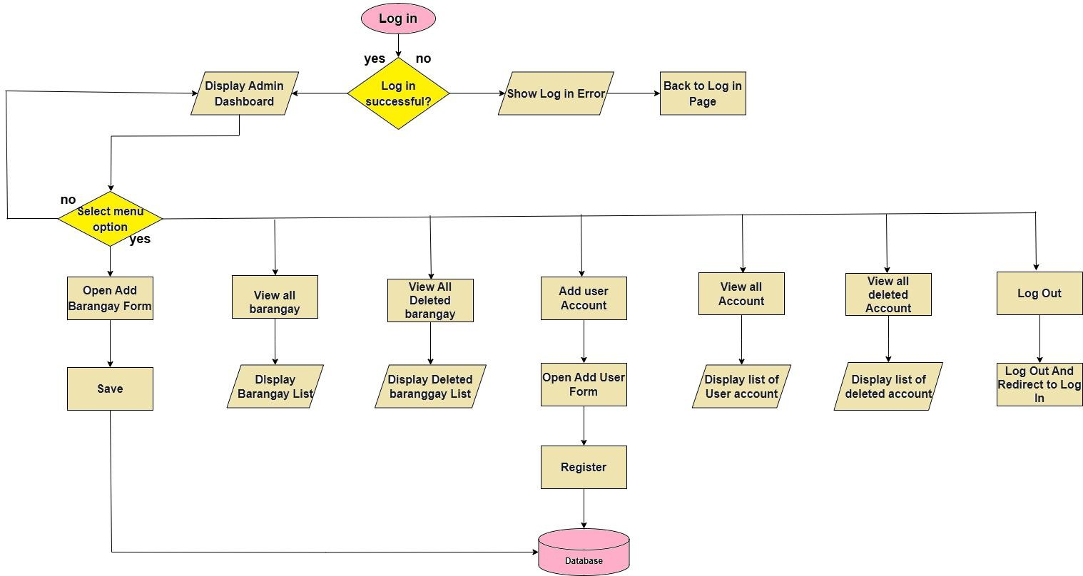

**Figure 2**. Admin presents the hierarchical input-process-output diagram of the

Bayani Onesys.

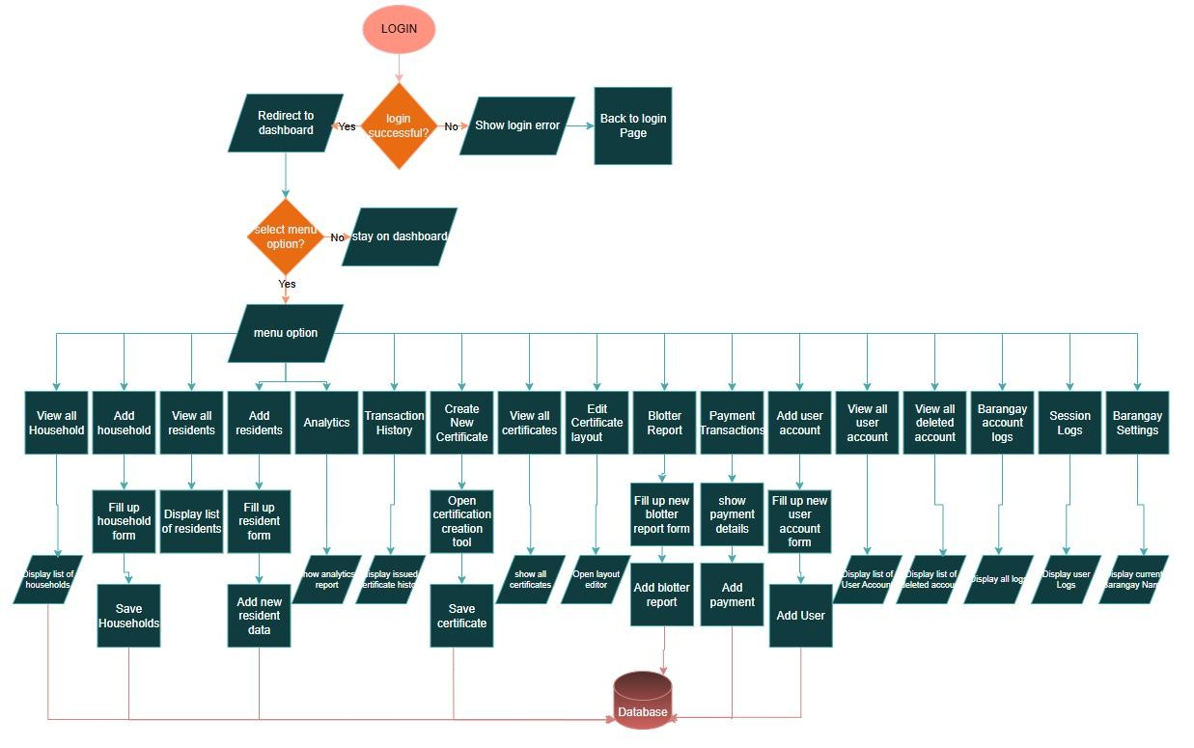

**Figure 3**. The barangay dashboard, input-process-output diagram of the barangay

officials

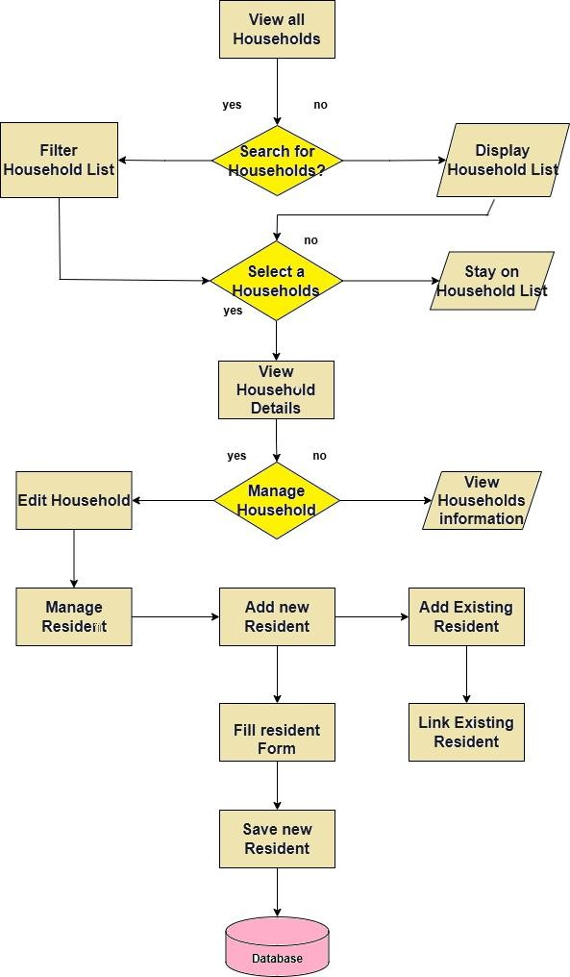

**Figure 4**. this is the barangay view and add household: this input-process-output diagram of the barangay officials

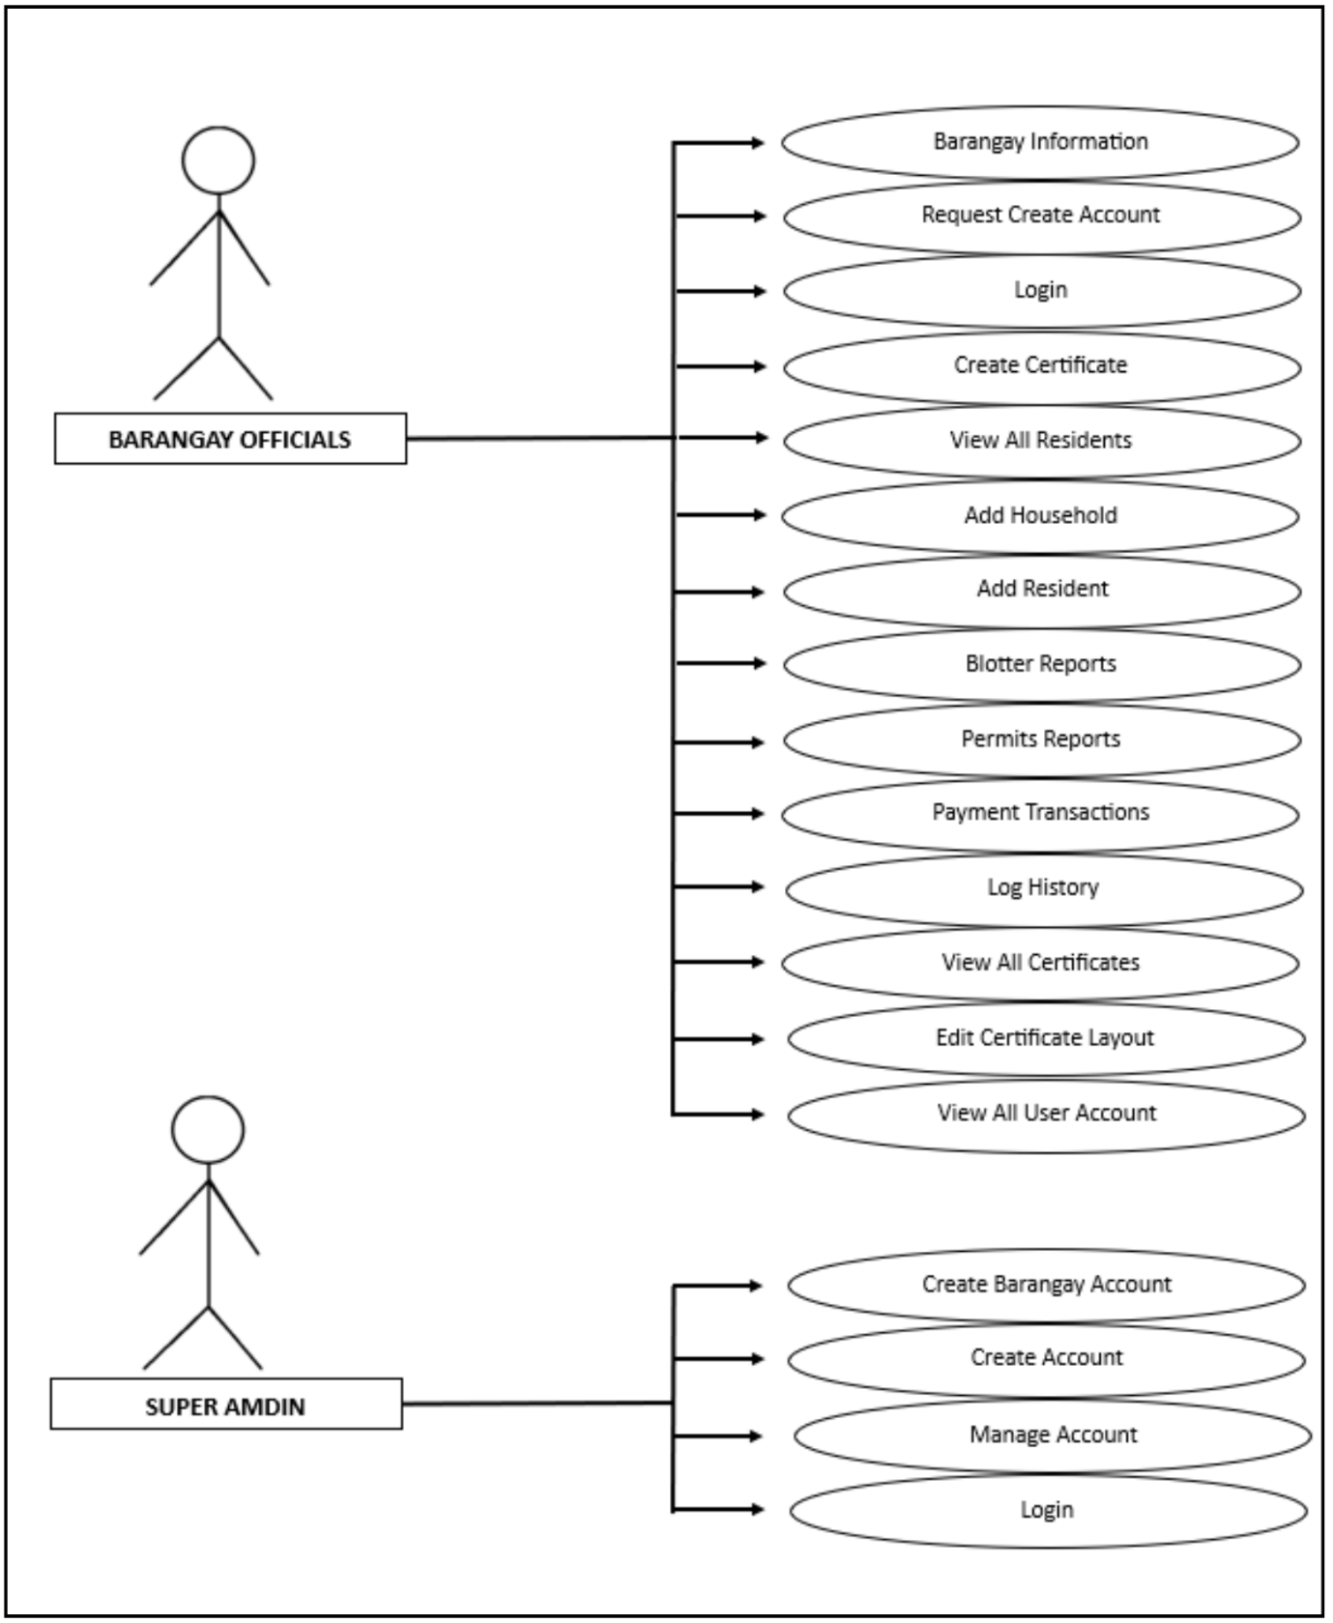

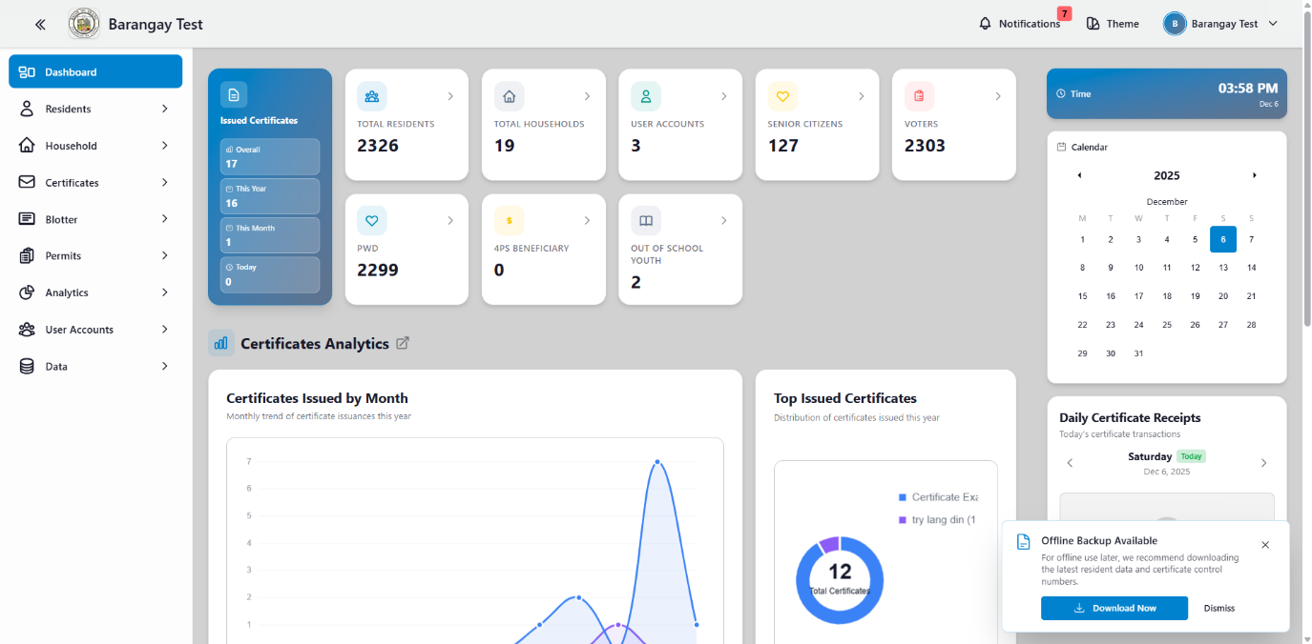**Figure 5.** The use case diagram of the Bayani Onesys website platform

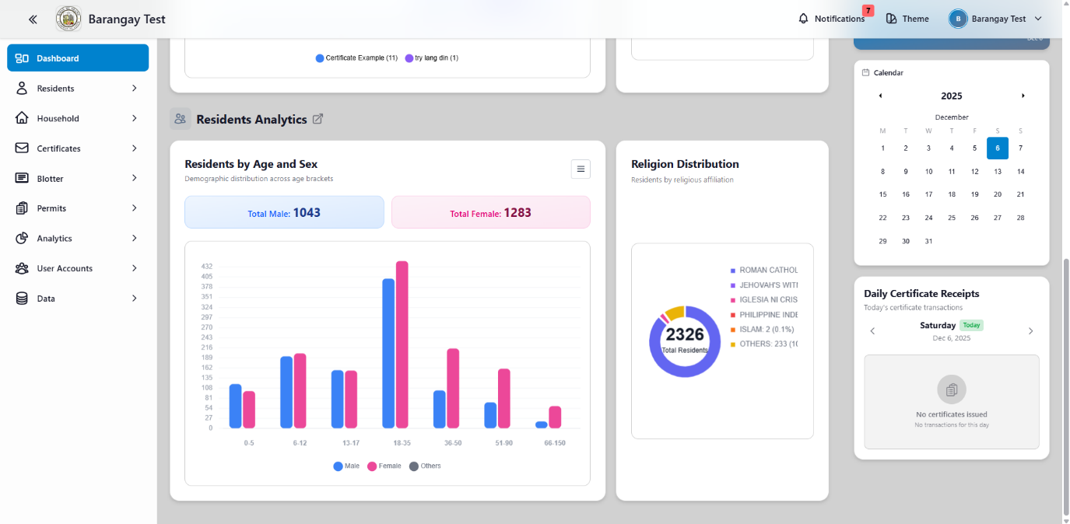

**Figure 6**. shows the graphical user interface design of the Onesys website platform this website platform is dashboard it shows the Total residents, Total households, Issued certificates, User accounts, Total number of Senior Citizens, Total number of Voters, Total number of PWD, Total number of 4Ps Beneficiary, Total number of Out of school youth, Issued certificates this year line graphs, Top issued certificate this year chart, Residents by age bracket and sex bar graph, Religion chart and Daily certificate receipts

**REQUIREMENTS ANALYSIS**

In this enhancement phase of the Bayani Onesys record management system, the research team conducted a detailed assessment of user needs to guide the integration of new features. While the core system is already functional, this phase aimed to improve its overall performance and usability based on actual user experience and evolving requirements.

The analysis included interviews and consultations with key stakeholders such as barangay officials and IT professionals. Their insights will helped refine the system to better align with real-world workflows and preferences.

|  |
| --- |
|  |
|  |  |

BAYANI ONSYS. The six main areas these causes are categorized are Materials, Methods, Machines, Measurement, Environment and People.

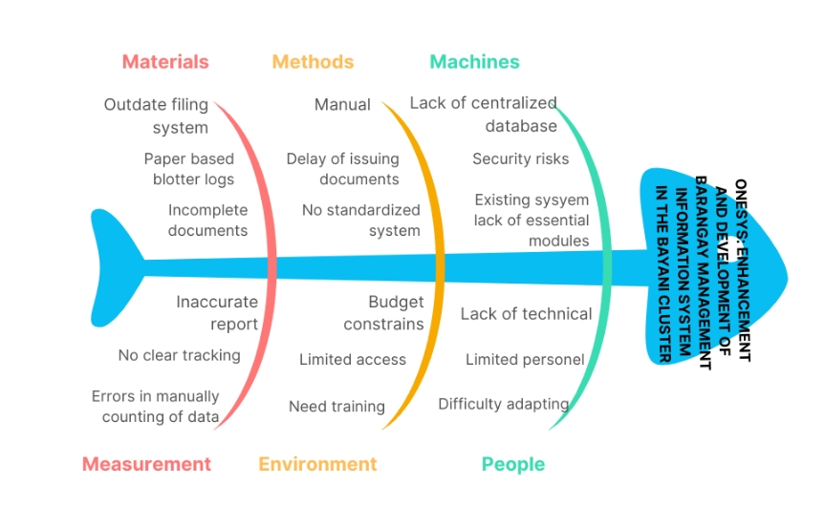

**Figure 7:** Fishbone Diagram of the Operational Feasibility of Bayani Onesys

The fishbone diagram highlights key inefficiencies in barangay record management, including outdated filing systems, manual processes, lack of a centralized database, and limited technical skills. Budget constraints and inaccurate reporting further hinder operations. Implementing the Bayani Onesys system addresses these issues by streamlining processes, enhancing security, and improving accessibility for more efficient governance.

**Key areas of focus for enhancement include:**

**Payment Integration** – Adding a module for tracking and processing payments related to barangay services.

**Daily Sales Summary** – Introducing automated tracking and reporting of total daily revenue.

**Blotter Management** – Integrating a detailed and secure blotter reporting module for incidents within the barangay.

**Permit Processing** – Enhancing the permit application and issuance workflow with tracking and document generation features.

## TECHNICAL FEASIBILITY

**Table 1**. The list of technical resources uses to run the project to be developed

|  |  |
| --- | --- |
| **Acer Laptop** | **Personal Computer** |
| 64-bit Windows 10 | 64-bit Windows 10 |
| Intel i3 7020U | Intel i5-4570 |
| 12 GB Ram | 8gb ram |
| 256GB HDD | 256gb Sata SSD |
|  | AMD RX 550 4gb |
|  |  |
|  |  |
| **Acer Laptop** | **Personal Computer** |
| **HP Laptop** |  |
| 64-bit Win 11 |  |
| i3-7020U |  |
| 8GB RAM |  |
| 256 SSD |  |

Table 1 presents the technical resources used in developing the system, highlighting the specifications of the Acer Laptop, HP Laptop, Asus Laptop, and a Personal Computer. These devices played an essential role throughout the development process. The Acer Laptop, equipped with a 64-bit Windows 10 operating system, Intel i3-7020U processor, 12 GB RAM, and a 256 GB HDD, provided sufficient capability for coding, testing, and documentation tasks. The Personal Computer, running on 64-bit Windows 10 with an Intel i5-4570 processor, 8 GB RAM, a 256 GB SATA SSD, and an AMD RX 550 4 GB graphics card, served as an additional resource that enhanced performance during more demanding development activities. The HP Laptop, operating on 64-bit Windows 11 with an Intel i3-7020U processor, 8 GB RAM, and a 256 GB SSD, offered portability and convenience for remote development work. These combined technical setups ensured efficient system development by providing the necessary computing power, storage capacity, and reliability.

## REQUIREMENT DOCUMENTATION

The enhancement of Bayani Onesys focused on improving the existing record management system by adding key features such as, tracking, daily sales reporting, blotter management, and permit processing. These additions aimed to strengthen streamline tasks, and provided a more efficient and user-friendly experience for barangay officials and users across various modules.

## SYSTEM DEVELOPMENT

The enhancement of the Bayani Onesys web-based platform followed the agile model, utilizing five iterative stages: planning, design, development, testing, and deployment. This model allowed the development team to continuously gather feedback and adapted improvements throughout each cycle. Applying this approach to the enhancement phase ensures that new features—such as payment, daily sales reporting, blotter, and permit modules—were effectively integrated, tested, and refined based on user need

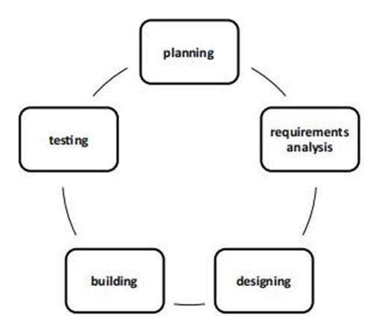

# Planning

In the planning stage, the researcher worked with the detailed planning of the exact task and features to be delivered to the intended user. Data gathering was conducted.

# Requirement’s analysis

The researcher collected more detailed information about the needs and requirements for the Bayani Onesys.

# Designing

Designing, the system architecture, user interface, and database structure are planned. Wireframes were developed to visualize how the system would function and ensure an intuitive user experience before actual development began

# Building

In this stage, the actual coding and system development were conducted based on the Agile framework. Developers worked iteratively to create modules or features, continuously integrating and improving the system throughout each cycle.

# Testing

The system underwent rigorous testing to identify and resolve bugs or errors. This included unit testing, integration testing, and functionality testing to ensure the system performed as expected.

# System testing

The researchers carefully tested the Bayani Onesys performance, usability, and usefulness throughout system testing to make sure that it ran smoothly and was convenient for barangay officials.

## System evaluation

The system was evaluated by barangay officials and an IT professor. Evaluators were randomly selected from different barangays and different barangay officials and IT professor from the DIT department at Cavite State University – Silang

Campus. (a) a

from the barangays, (b) a secretary from the barangay, and (c) an IT professor from the DIT department.

The IT professor evaluators of the developed Web Application were: (a) graduate of Computer Science, Information Technology or any computer related courses, (b) teaching IT related subjects in his/her field of specializations. The barangay officials who evaluated the developed web application system were selected from a sample of different barangays in Silang, Cavite.

**Data analysis plan**. Table 3 presents the response options for the analysis plan, indicating their degree of agreement based on the indications using a 5-point scale that defines the following:

5 – Highly Acceptable. Indicated that the End user, subject matter experts, and IT experts perceived the required functions to be perfectly working.

4 – Acceptable. Indicated that the End user, subject matter experts, and IT experts perceived the required functions are working very well.

3 – Moderately Acceptable. Indicated that the End user, subject matter experts, and IT experts perceived the required functions are working but could be improved.

2 – Fairly Acceptable. Indicated that the End user, subject matter experts, and IT experts perceived the required functions are working but encounters problem and needs minor improvement.

1 – Unacceptable. Indicates that the End user, subject matter experts, and IT experts the required functions are needing major improvement.

The mean ratings were interpreted and describe based on their level of perceptions on the given indicators as follows: 4.50-5.00 Highly Acceptable, 3.50 4.49 Acceptable, 2.50-3.49 Moderately Acceptable 1.50-2.49 Fairly Acceptable, 1.00-

1.49 Unacceptable.

**Table 2.** Descriptive interpretation of the mean

|  |  |  |
| --- | --- | --- |
| **Weight** | **NUMERICAL VALUE** | **VERBAL INTERPRETATION** |
| 5 | 4.50 – 5.00 | Highly Acceptable |
| 4 | 3. 50 – 4.49 | Acceptable |
| 3 | 2.50 – 3.49 | Moderate Acceptable |
| 2 | 1.50 – 2.49 | Fairly Acceptable |
| 1 | 1.00 – 1.49 | Unacceptable |

## Implementation Plan

The Table 2 shows the implementation of the BAYANI ONESYS that how to implement the system to the client and provide a sufficient documentation for the researchers.

**Table 3.** Implementation Plan

|  |  |  |  |
| --- | --- | --- | --- |
| **STRATEGY** | **ACTIVITY** | **PERSON INVOLVED** | **DURATION** |
| Approval from the barangay officials | Letter | Researchers, barangay officials | 1 Day |
| Barangay session | System Presentation | Researchers, barangay officials | 1 Hour |
| System installation | Give Account and Access to their own system | Researchers, barangay officials | 30 Mins |
| 3 Day training | Hands on Training and Lectures. | Researchers, barangay officials | 3 Days |

**RESULTS AND DISCUSSION**

This chapter presents the project description and structure, capabilities andlimitations, and overall evaluation of the system based on its performance and user experience.

## System Design

The system was designed to make data easy to access, accurate, and manageable for daily barangay operations. It aimed to replace the manual processes with a centralized platform where records could be stored, updated, and retrieved efficiently.

The web-based system describes the Bayani Onesys system's features, components, and user interface. It contains twenty-two (22) modules such as: Dashboard, View All Residents, View All Household, Certificates Types, Certificates Layout, Certificates History, Blotter Dashboard, Blotter Reports, Summon Types, Summon Layouts, Permit Dashboard, Permit Applications, Permit Certificate Types, Certificates Analytics, Residents Analytics, User Accounts, User Types, Resident Data, Household Data, Household Residents Data, Certificate Types Data and Issued Certificates Data.

1. **Show the main page of the Onesys**

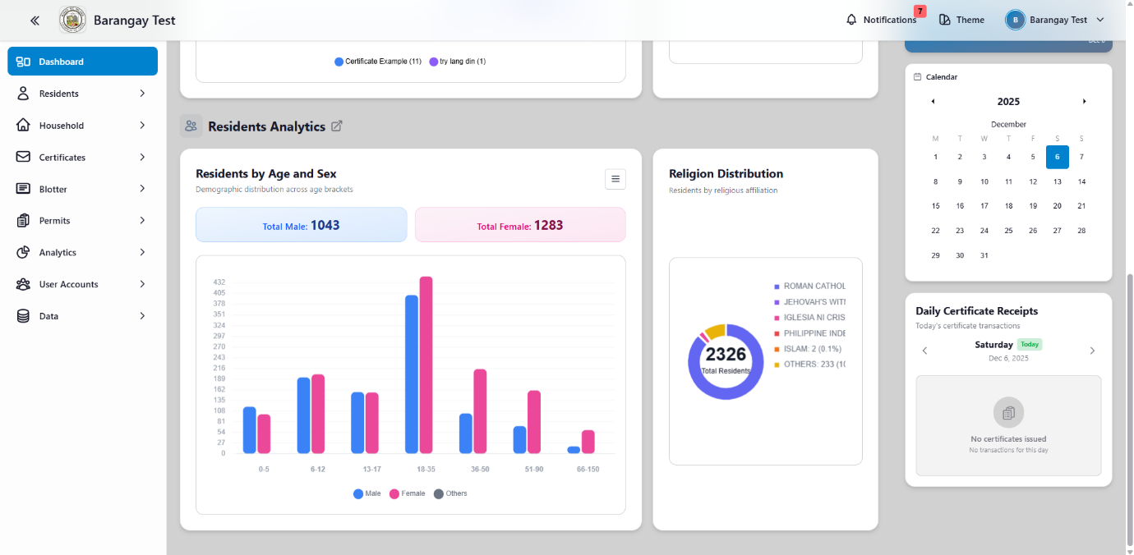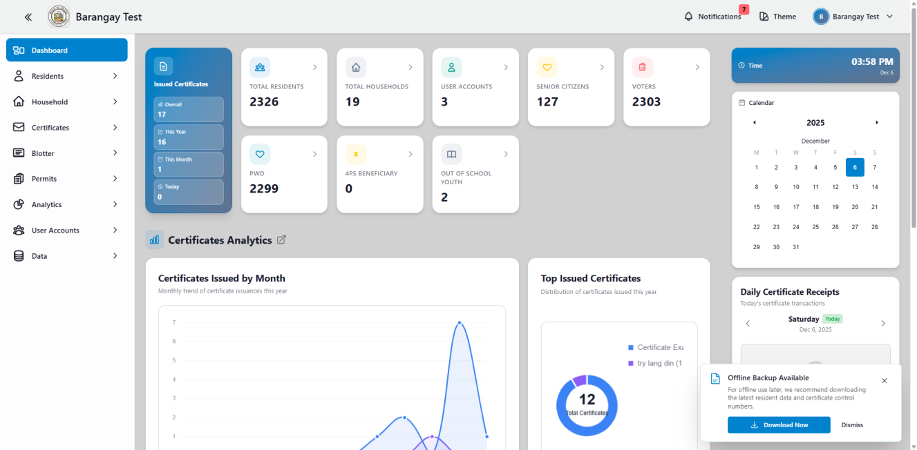

**Figure 8**. Dashboard

**Figure 8.** shows the Dashboard of the Bayani Onesys System and Total residents, Total households, Issued certificates, User accounts, Senior Citizens, Voters, PWD, 4Ps Beneficiary, Out-of-school youth, Issued certificates this year line graphs, Top issued certificate this year chart, Residents by age bracket and sex bar graph, Religion chart, and Daily certificate receipts

1. **Show the view all resident**

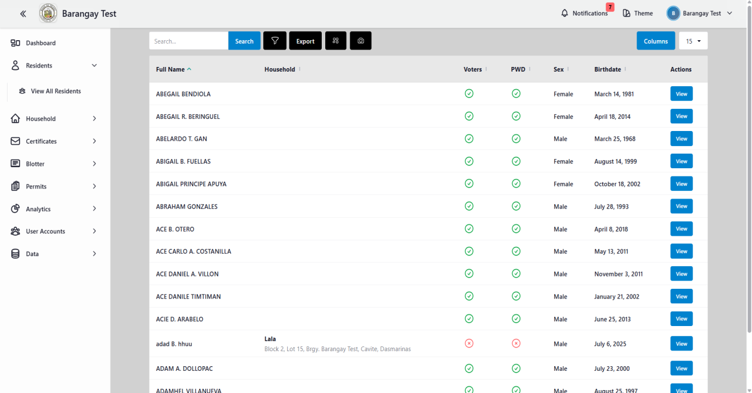

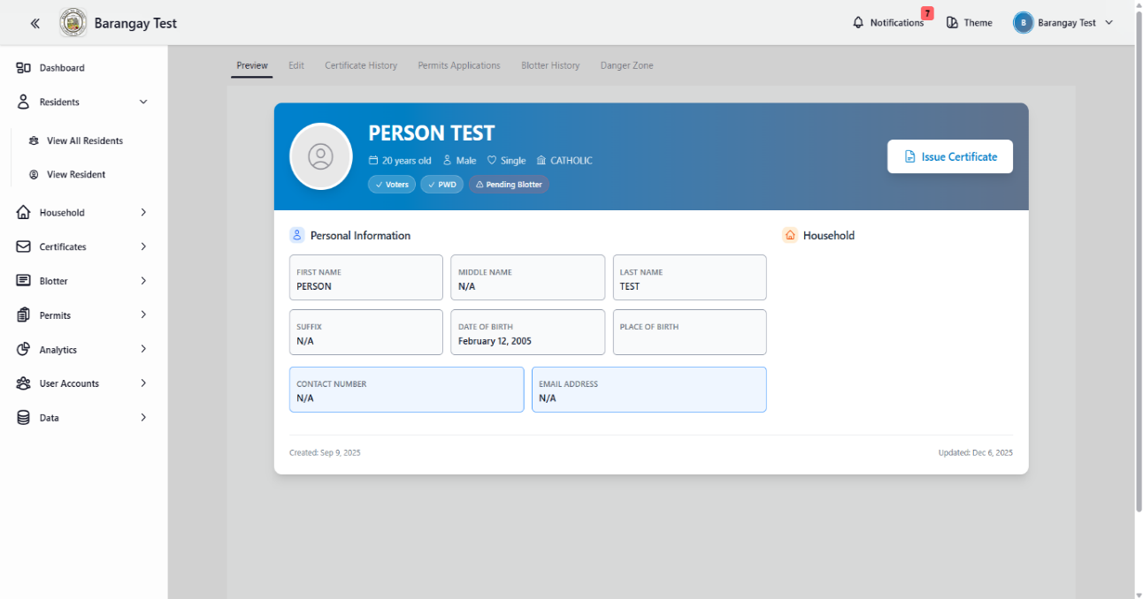

**Figure 9.** View All Residents

Figure 9 shows the list of the resident data, including a picture icon for viewing the image of the residents, a tiles icon for switching to a large view icon for easier browsing, export buttons for saving the data, view buttons for accessing the complete resident details and search bar feature for locating records quickly and efficiently.

**C. Show all the list view all household recorded in the system**

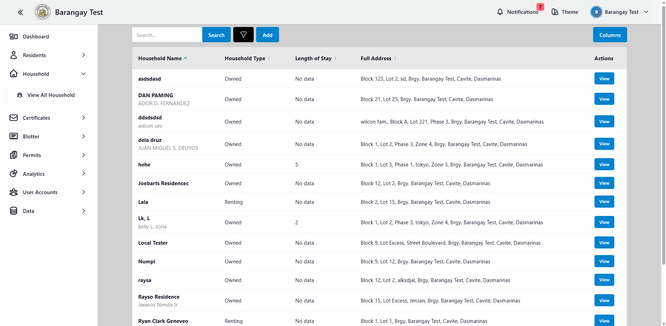

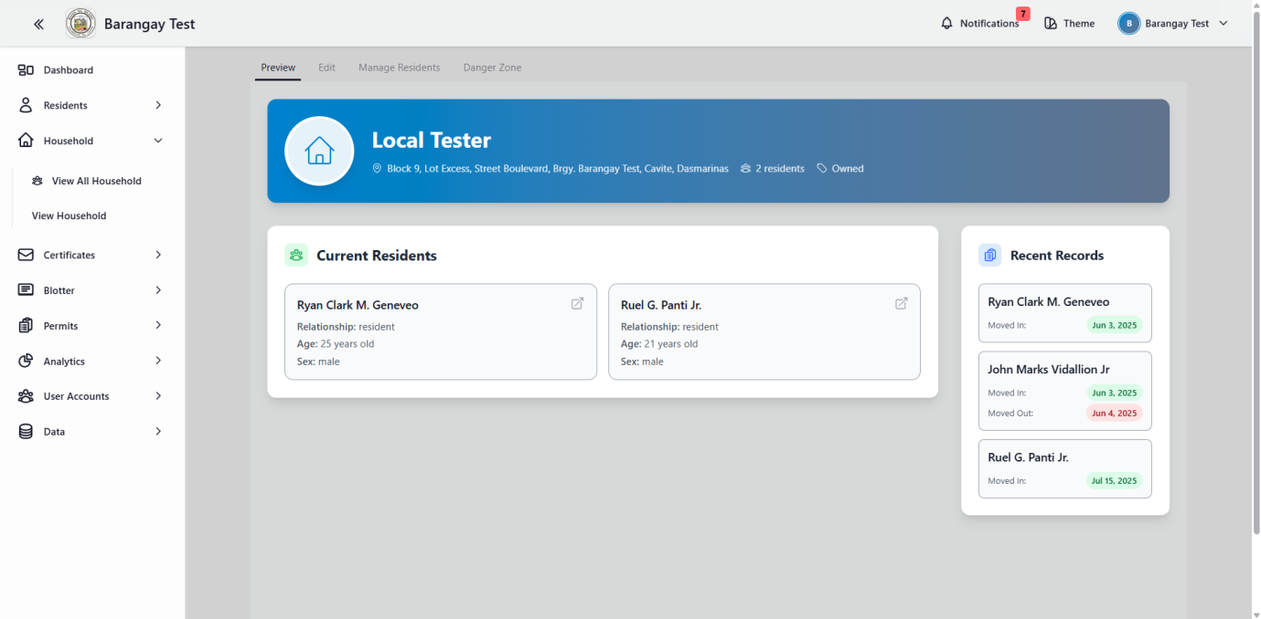

**Figure 10.** View household

Figure 10 shows the household view, which included an add button for entering household details and addresses, a filter icon for narrowing down specific information, and a search bar feature to search easily.

**D. Show all the certificate type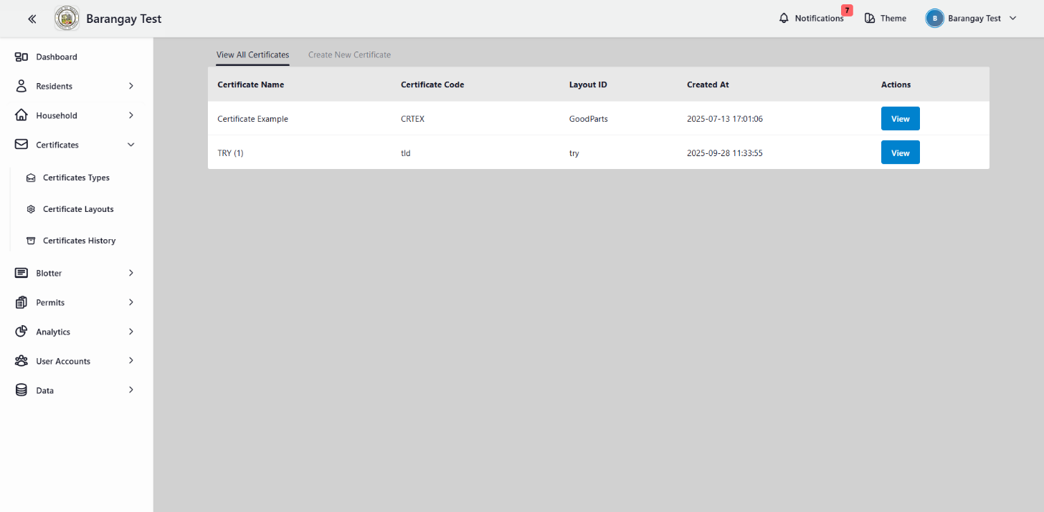 in barangays**

**Figure 11.** Certificates types

Figure 11 shows all the certificate types that were created and saved in the system.

**E. Show all the certificate layout in barangays**

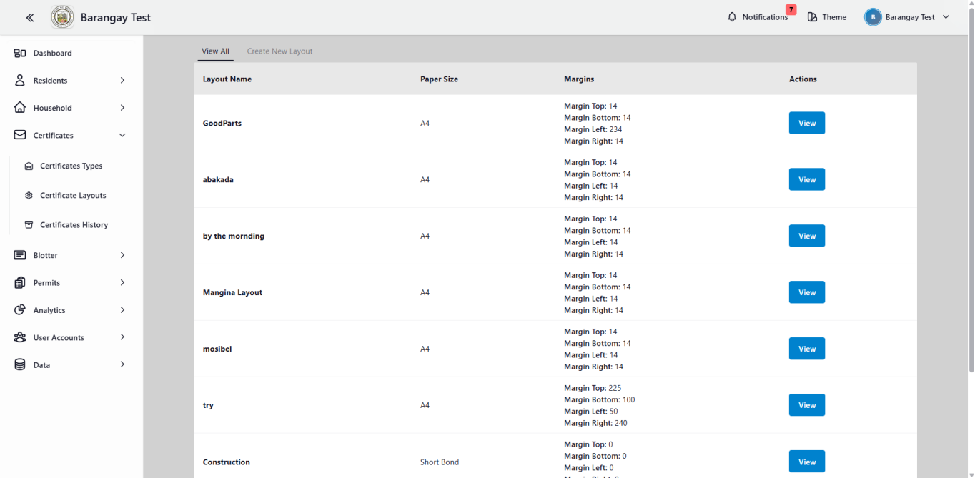**Figure 12.** Certificate layout

Figure 12 show the layout of the certificate based on the existing template used by each barangay. This allows the system to follow the barangay’s official design and adjust to the specific paper size required for their certificates.

**F. Show all the certificate issued**

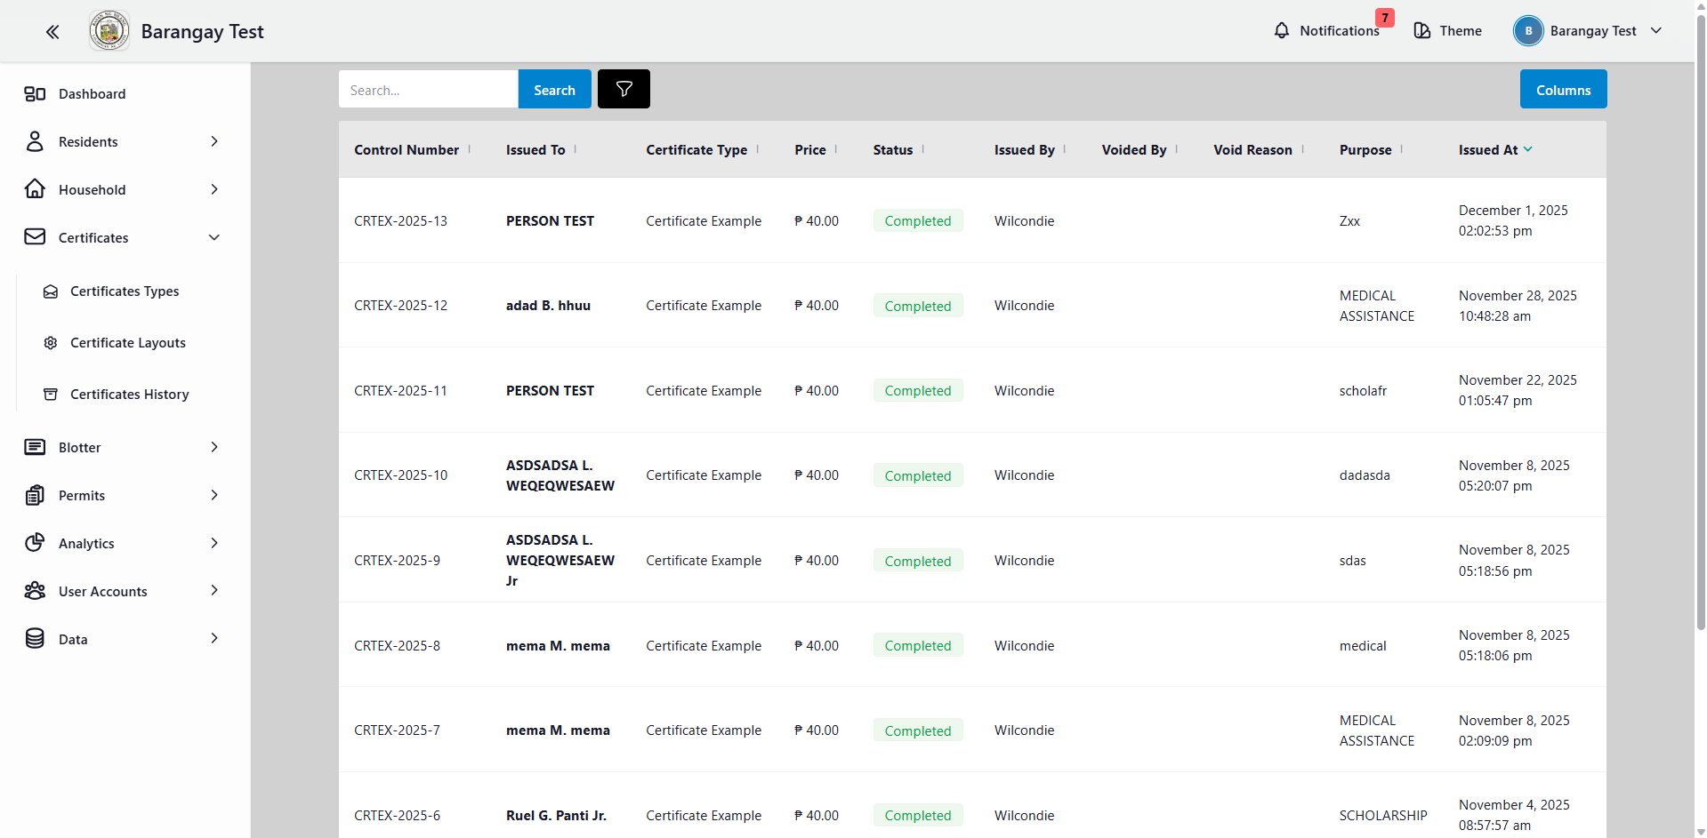

**Figure 13.** Certificate history

Figure 13 shows all the certificates that have been issued through the system. It provides a complete record of past transactions, helping barangay staff track, review, and verify previously released documents whenever needed.

**G. Show the blotter dashboard**

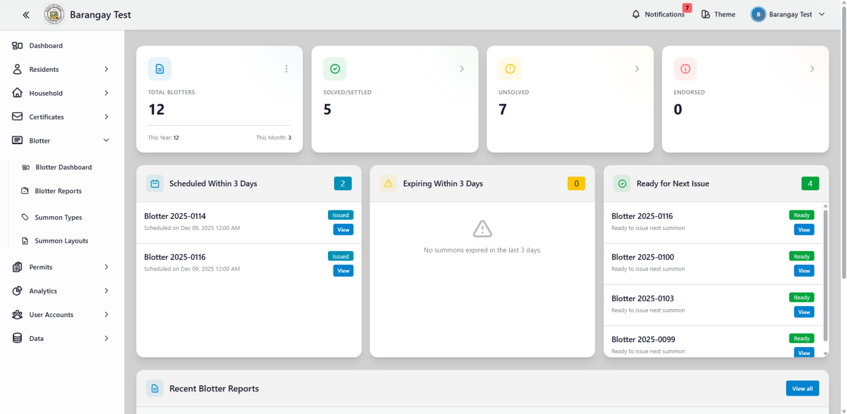

**Figure 14.** Blotter dashboard

Figure 14 shows the Blotter Dashboard of the system. It displays an overview of blotter-related activities, including the total number of blotters recorded, how many cases are solved or settled, the number of unsolved cases, and those that have been endorsed. The dashboard also highlights the list of individuals who are summons scheduled within the next three days, summons that will expire in next 3 days and ready to issue next summon, showing their names, corresponding blotter numbers, and view buttons for quick viewing. Additionally, the dashboard includes a section for recent blotter reports, showing details such as the type of incident, complainant, respondent, date and time, status, and a view button for more detailed information.

**H. Show the list blotter reports recorded in the system**

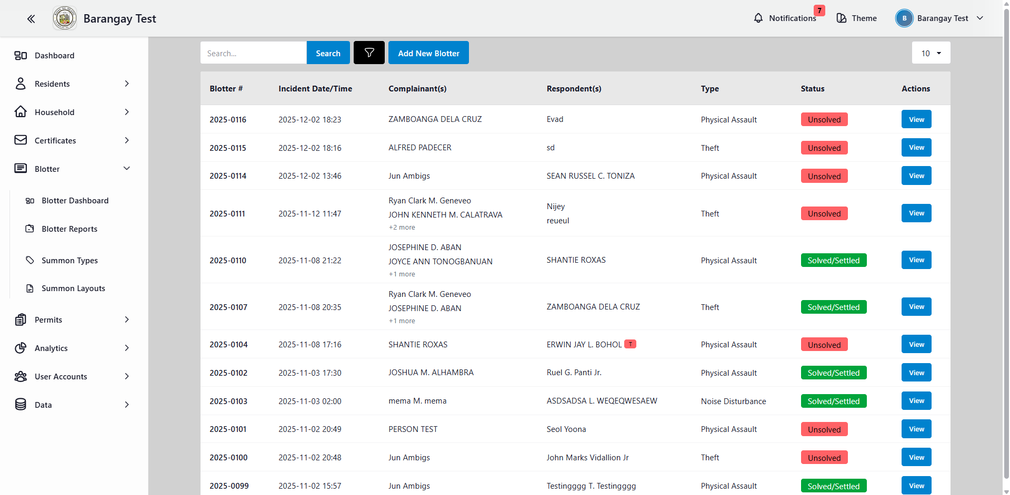**Figure 15.** Blotter Reports

Figure 15 shows the complete list of all blotter reports recorded in the system. The page displays detailed information for each incident, including the blotter number, incident date and time, complainant(s), respondent(s), and the type of case filed. It also highlights the current status of every report—whether it is *Solved/Settled*, *Unsolved*, or *Endorsed*—with color-coded labels for easy identification. A search bar is included at the top to help users quickly find specific records, while the "Add New Blotter" button allows authorized personnel to input new cases. Each entry also includes a **View** button that provides access to the complete details of the blotter, allowing barangay officials to review, update, or manage the case efficiently.

**I. Show all the list of summon types in barangays**

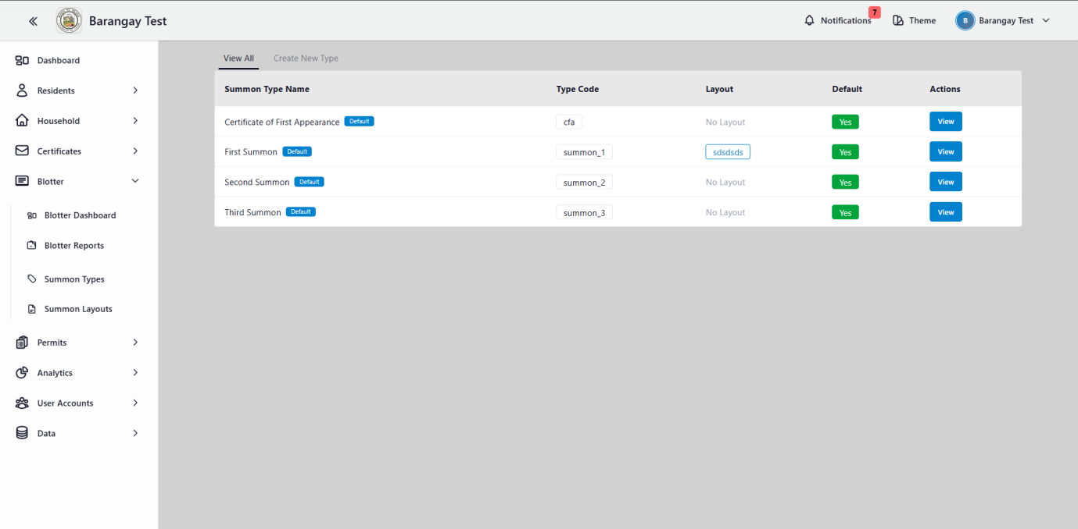**Figure 16.** Summon Types

Figure 16 shows all the summon types provided by the barangay. It displays the complete list of summon categories, including summon type names, assigned type codes, layout availability, and whether they are set as default. also includes action buttons like “View” to allow officials to quickly review each summons details.

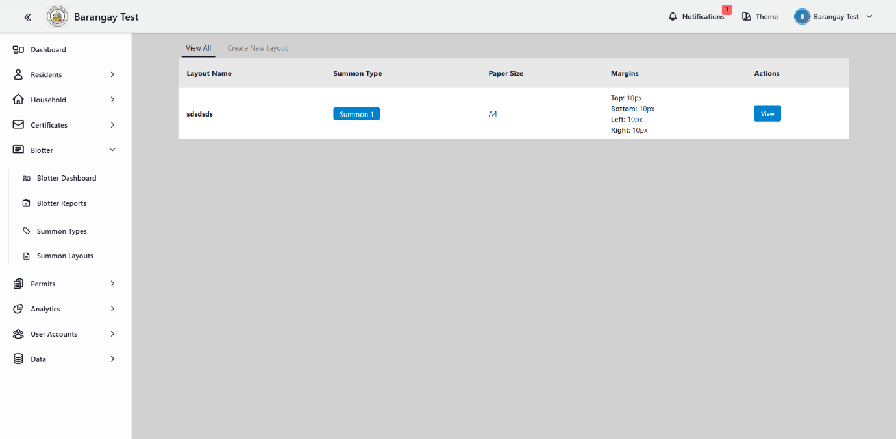**J. Show the summon layout**

**Figure 17.** Summon Layout

Figure 17 show the summon layout provided by barangays

**K. Onesys Permit Dashboard Overview**

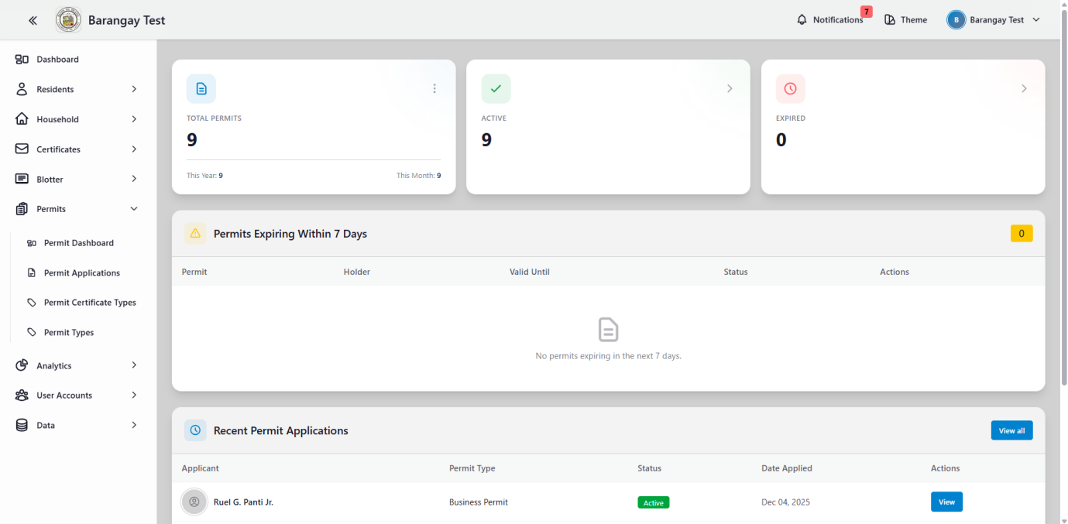

**Figure 18. Permit Dashboard**

Figure 14 shows the Permit Dashboard of the system. It displays an overview of business permit-related activities, including the total number of permits, active permit, and expired permits. The dashboard also highlights the list of individuals that will expired within the next seven days. Additionally, the dashboard includes a section for recent permit applications, showing details such as the Applicant name, permit type, status, date applied, and a view button for more detailed information.

**L. Show all the list of permit application**

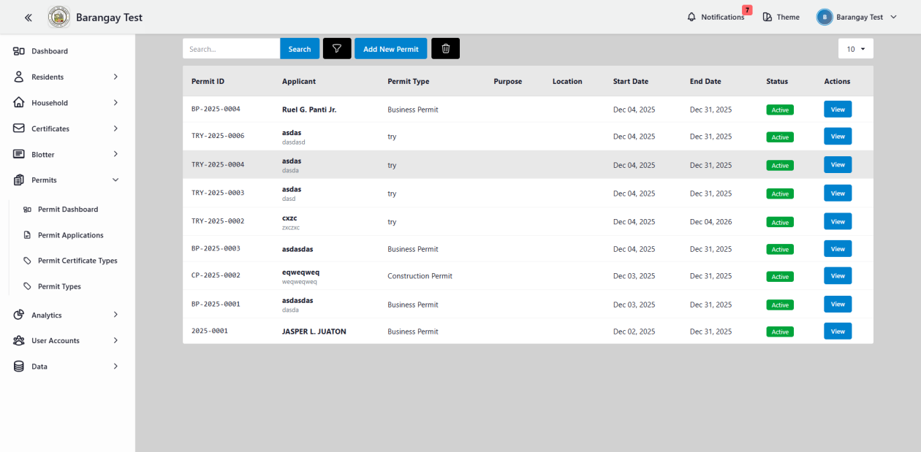

**Figure 19. Permit Applications**

Figure 19 shows the complete list of all Permit Application in the system. The page displays detailed information for each applicant, including the permit id, Applicant name, Permit type, Purpose, Location, Start date, End date, status, and **View** button that provides access to the complete details of permit applicant, allowing barangay officials to review, update, or manage the case efficiently. The "Add New Permit" button allows authorized personnel to input new Applicant.

**M. Show the list of permit certificate types**

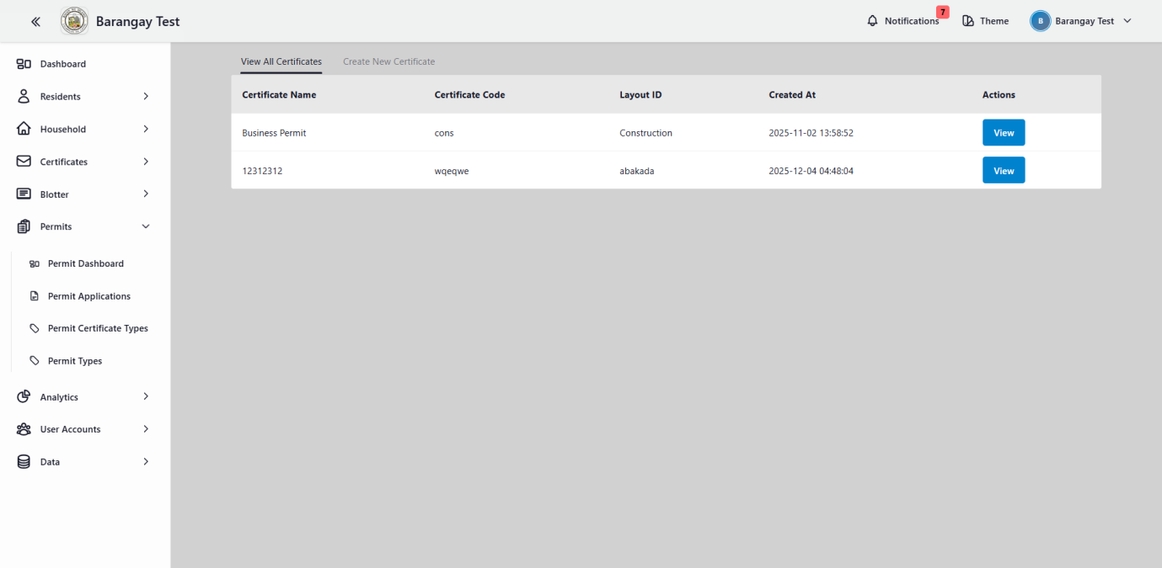

**Figure 20. Permit Certificate Types**

Figure 20 shows all the permit certificate types provided by the barangay. It displays the complete list of all permit certificates that barangays provide, including certificate names, assigned type codes, layout availability, and created at and action buttons like “View” to allow officials to quickly review each certificate details.

**N. Show the list of permit types**

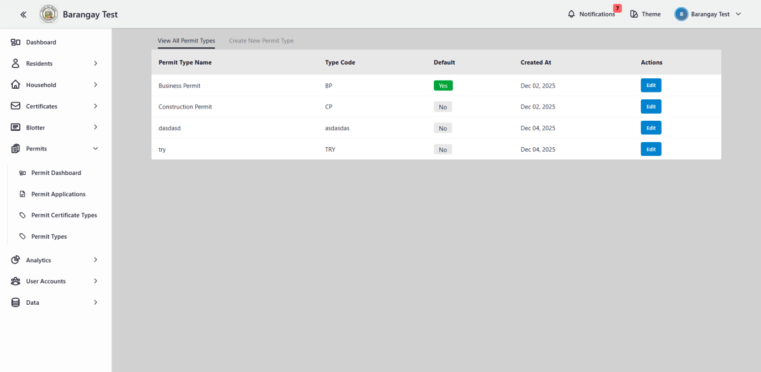

**Figure 21. Permit Types**

Figure 21 show the permit types layout provided by barangays

**O. Show the certificate analytics**

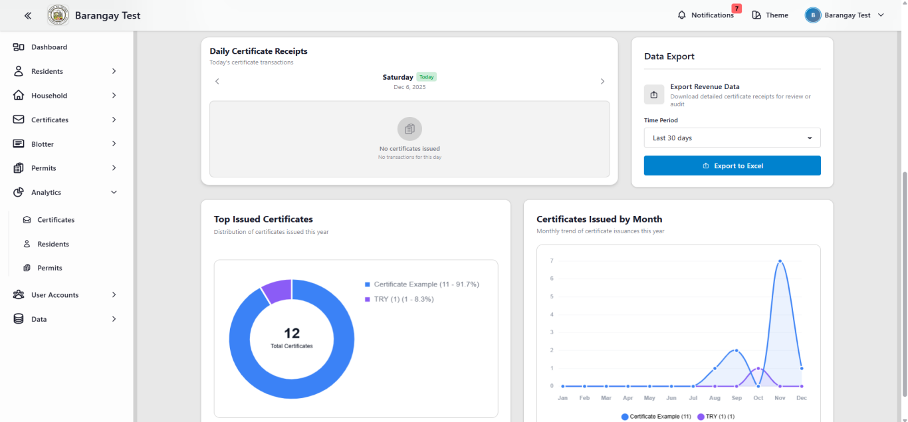

**Figure 22.** Certificate analytics

Figure 22 shows the top-issued certificates for the year through a pie graph that highlights the total count for each certificate type. It also includes a line graph displaying the monthly distribution of issued certificates.

**P. Show the resident analytics**

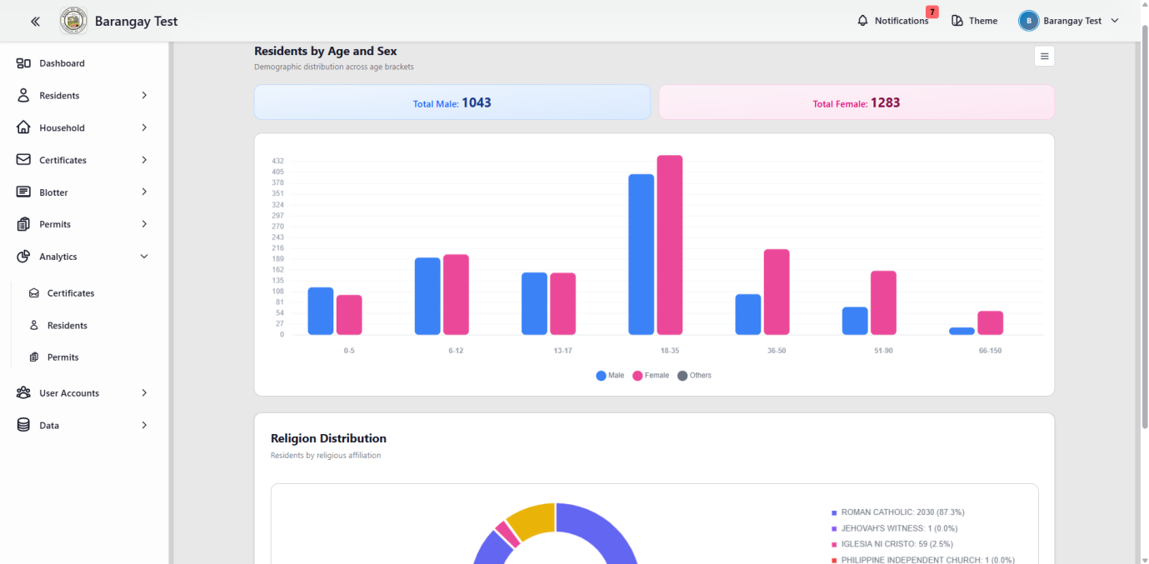

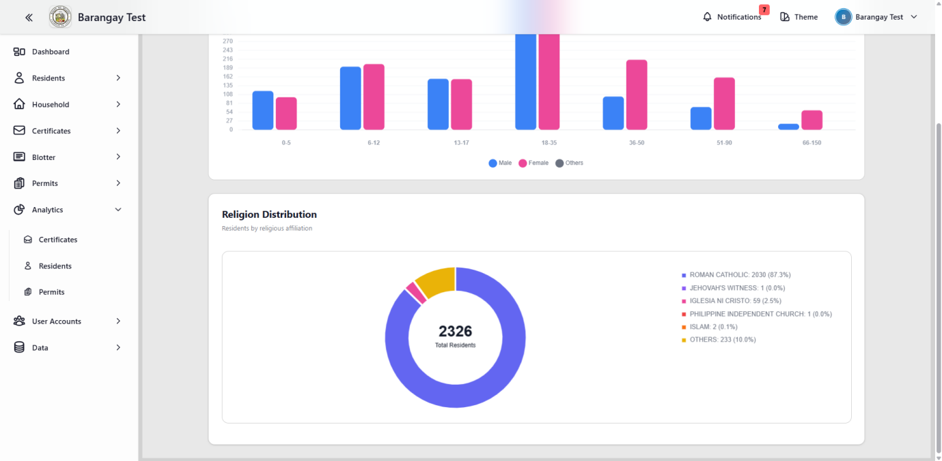

**Figure 23.** Resident analytics

Figure 23 shows the total number of female and male residents, along with a bar graph that presents the population distribution by age bracket and sex. It also includes a pie chart for religion, highlighting the total count and percentage of each religious group within the barangay.

**Q. Show the permit analytics**

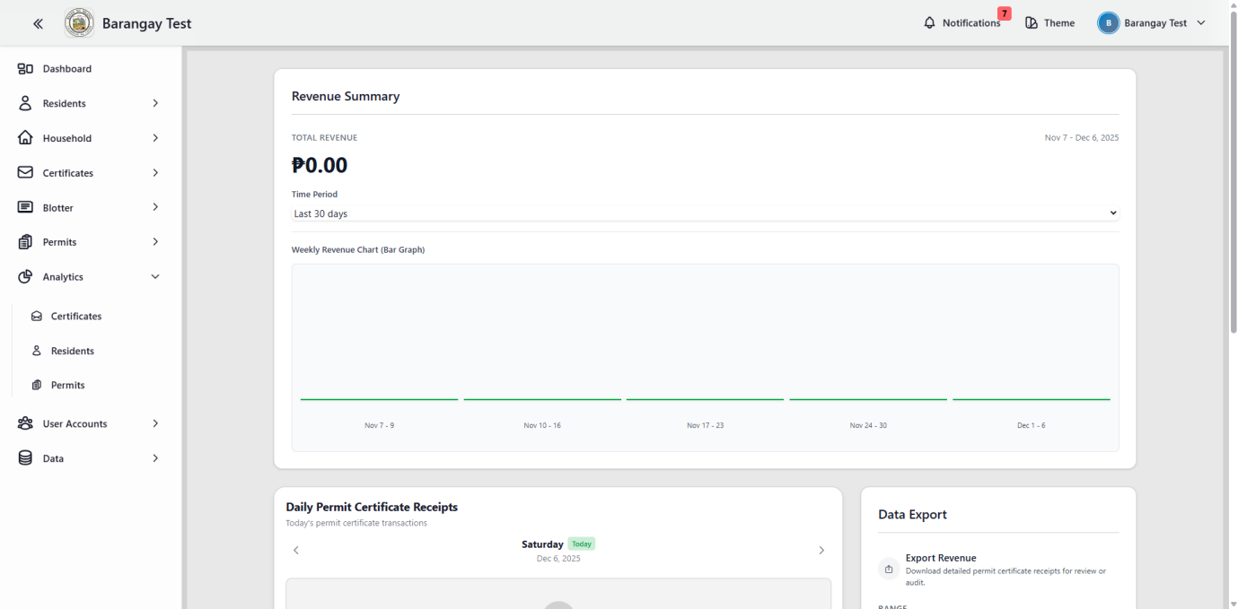

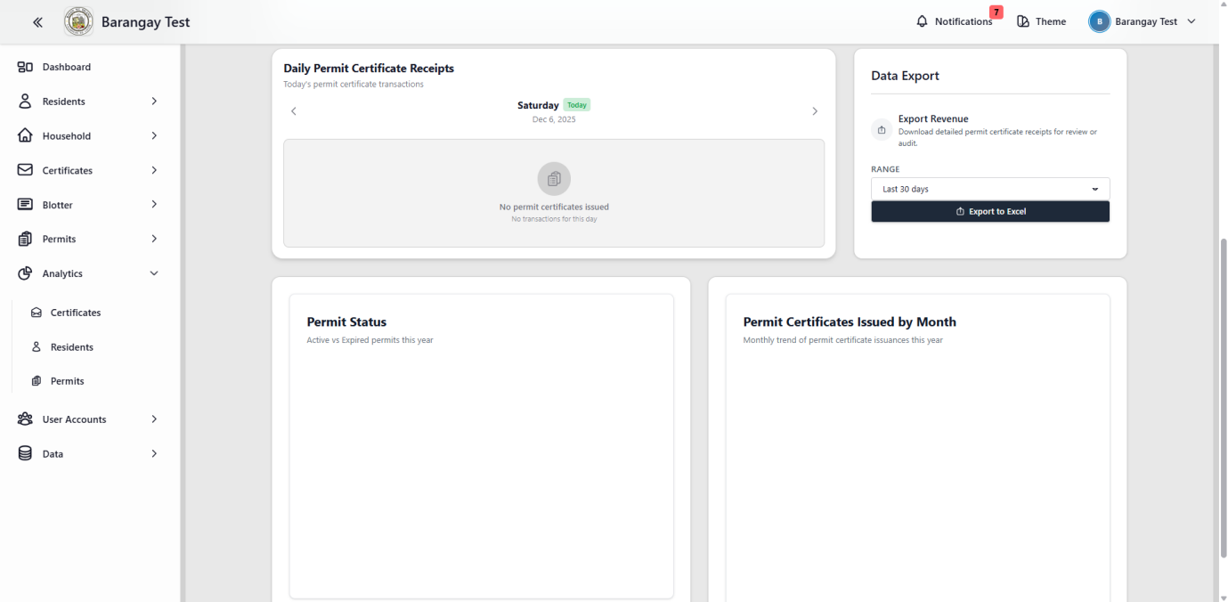

**Figure 24.** Permit Analytics

Figure 24 shows a detailed overview of permit analytics, On top weekly revenue bar graph at the top and the Daily Permit Certificate Receipts that displays the number of certificates issued for the day. On the right side, the Data Export panel allows users to download permit certificate records, and Permit Status chart, showing the total active and expired permits.

**R. Show all the user accounts**

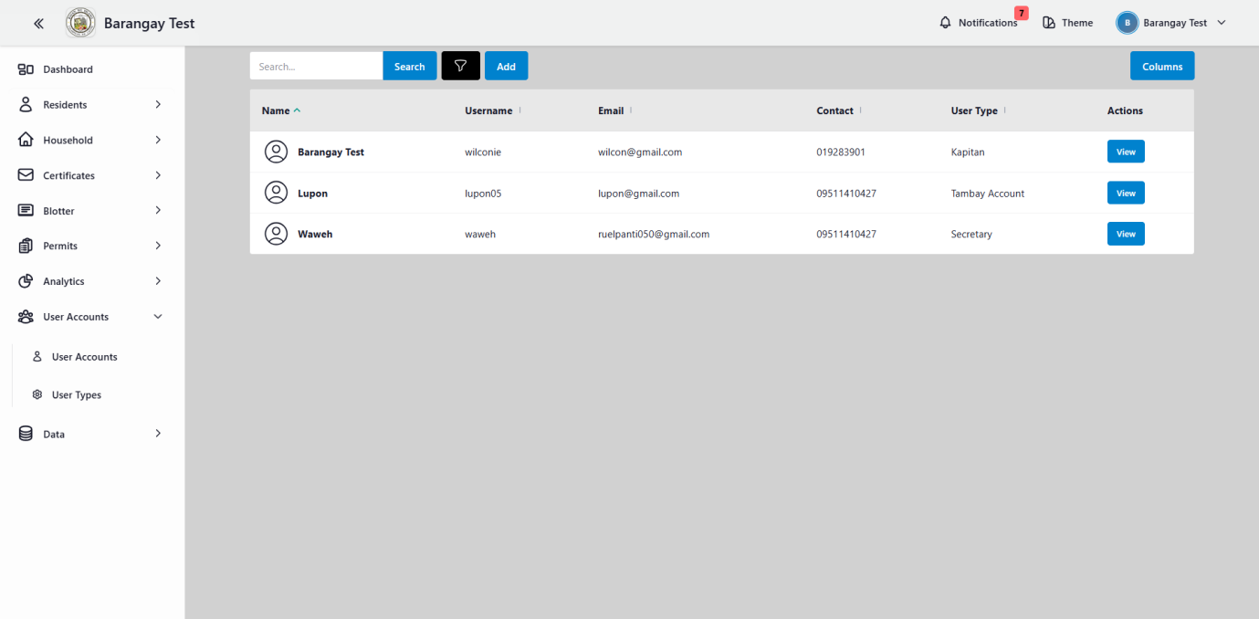

**Figure 25.** User accounts

Figure 25 shows the list of all registered user accounts in the system. It includes the details of the user, such as their name, username, email, contact number, and also the assigned user type or role. Also it has a search bar for quickly locating records, a filter button to display specific details, add button for creating new user accounts, and a view button that allows administrators to review and manage user access efficiently.

**S. Show the resident analytics**

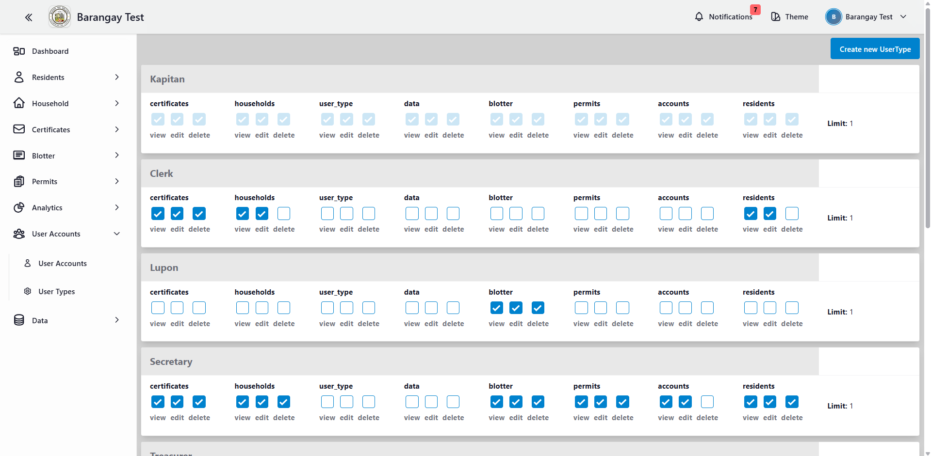

**Figure 26.** User types

Figure 26 shows the different user types in the system along with their corresponding access permissions. Each role has specific privileges such as viewing, editing, or deleting data across modules like certificates, households, user types, blotter reports, permits, accounts, and residents.

**T. Import Resident Data**

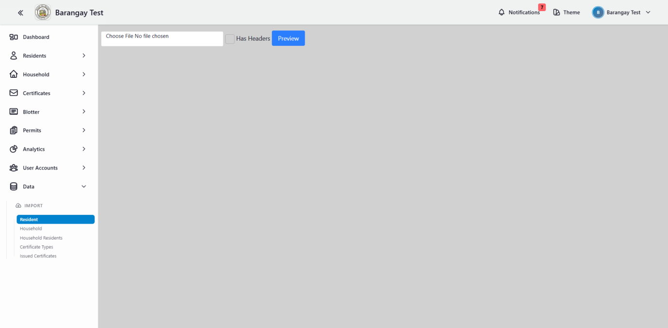

**Figure 27.** Import resident data

Figure 27 shows the import feature used for uploading resident data through an Excel file. It includes a file selection input, an option to indicate whether the file contains headers, and a preview button that allows users to check the data before finalizing the import.

**U. Import Household Data**

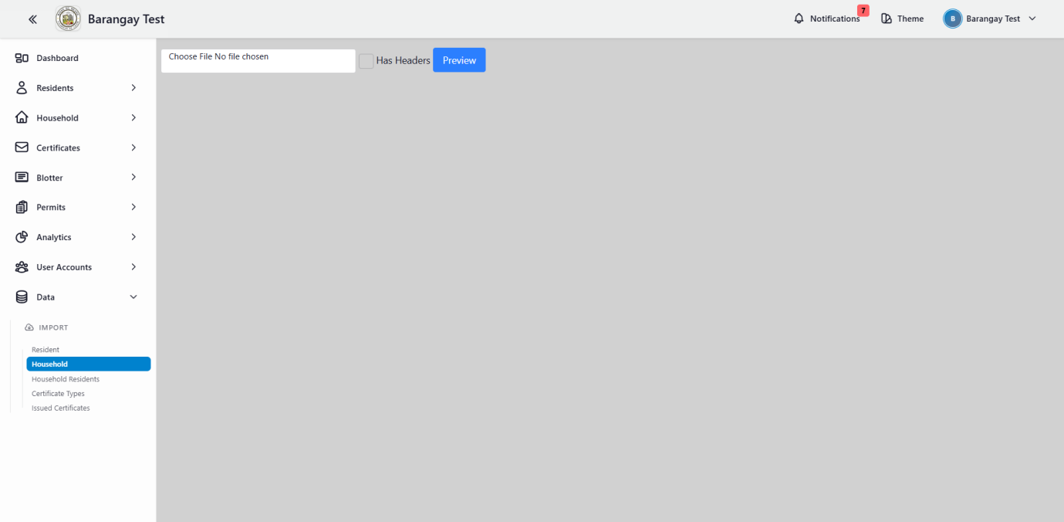

**Figure 28.** Household

Figure 28 shows the import feature used for uploading household data through an Excel file.

**V. Import Household Residents Data**

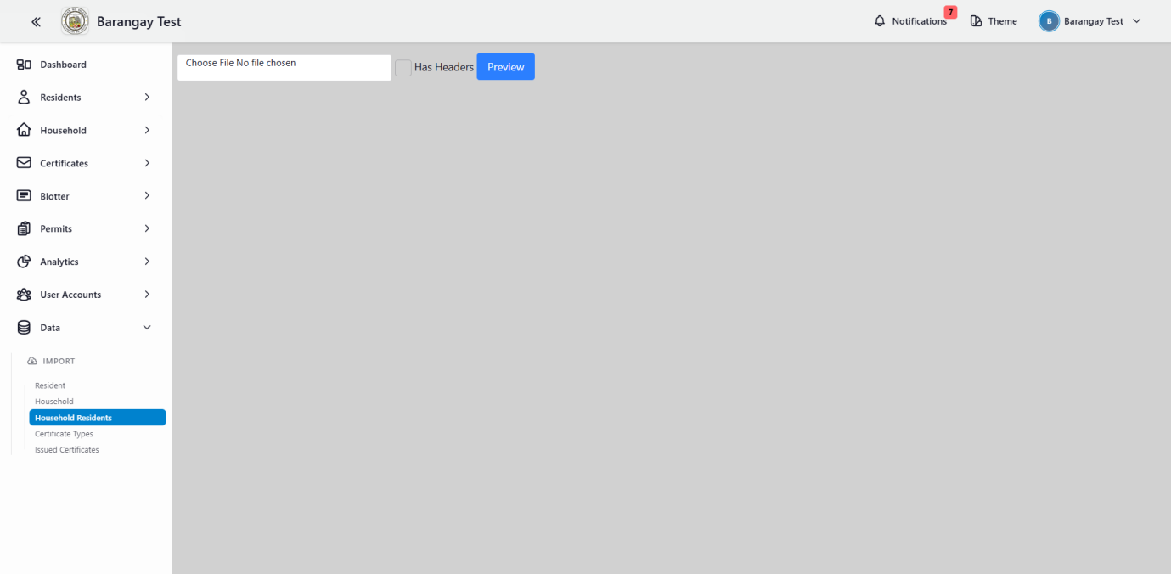

**Figure 29.** Household residents

Figure 29 shows the import feature used for uploading household resident’s data through an Excel file.

**W. Import Certificate Types**

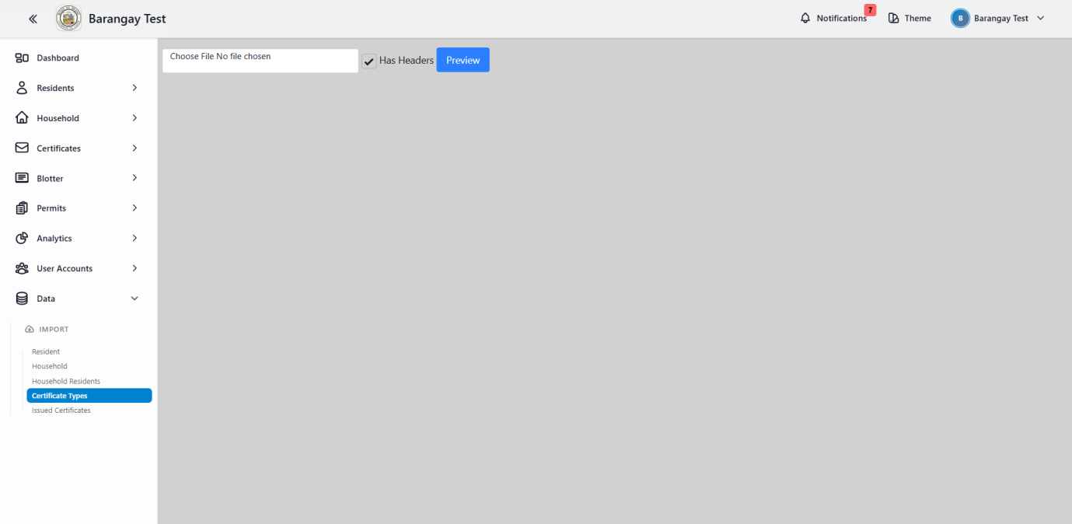

**Figure 30.** Certificate types

Figure 30 shows the import feature used for uploading certificate types data through an Excel file.

**X. Import Issued Certificates**

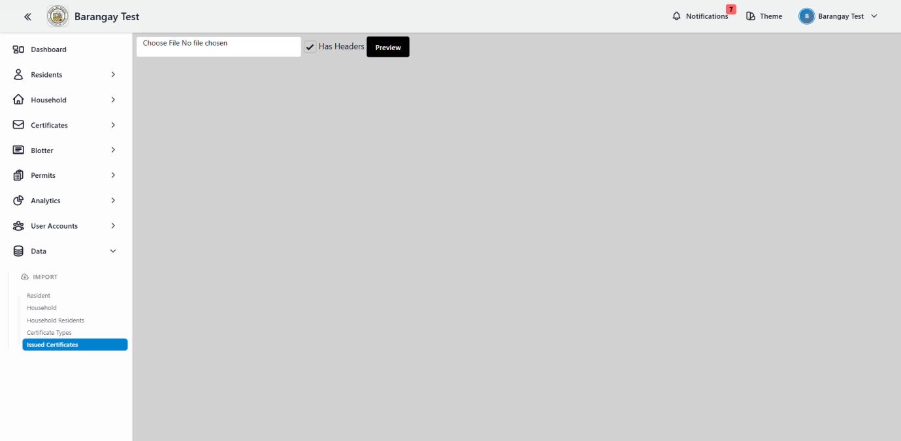

**Figure 31.** Issued certificates

Figure 31 shows the import feature used for uploading issued certificates data through an Excel file.

**System Development**

The system was developed with essential features and robust security measures to protect the records from unauthorized access, errors or failures, and corruption of data.

The web-based system used the Agile development model, which guided the researcher through iterative development cycles. This approach ensured that improvements were made after each testing phase, allowing the system to continuously evolve and function more efficiently. The research team collected and analyzed user requirements and real barangay data to ensure the system met practical needs. This process culminated in the development of **ONESYS: ENHANCEMENT AND DEPLOYMENT OF BARANGAY MANAGEMENT INFORMATION SYSTEM IN THE BAYANI CLUSTER**

1. **Visual Studio code for website application development**

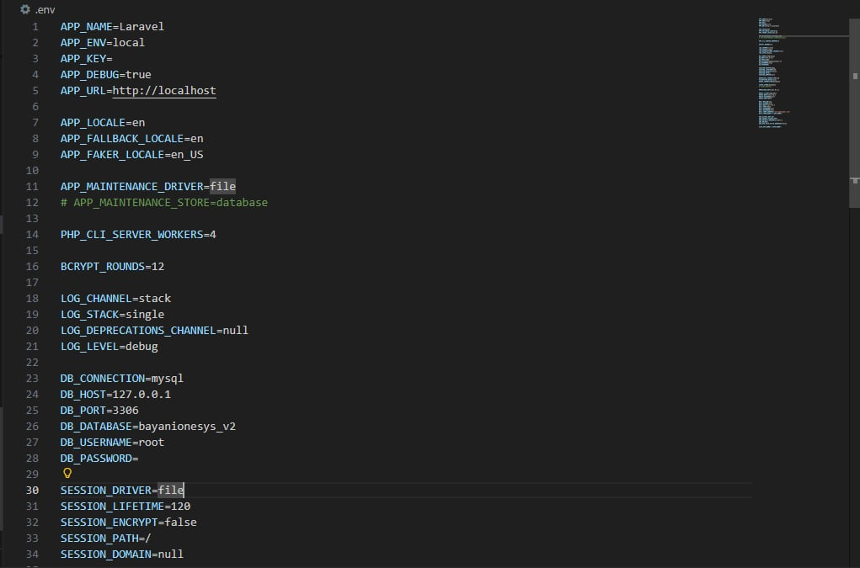**Figure 32.** Visual Studio Code

Figure 32 shows the development environment used for building the Bayani Onesys web-based system. Visual Studio Code served as the primary tool for creating the project, allowing the researcher to develop the system module by module and design its overall architecture. Through VS Code, various components were organized and implemented, including Dashboard, View All Residents, View All Household, Certificates Types, Certificates Layout, Certificates History, Blotter Dashboard, Blotter Reports, Summon Types, Summon Layouts, Permit Dashboard, Permit Applications, Permit Certificate Types, Certificates Analytics, Residents Analytics, User Accounts, User Types, Resident Data, Household Data, Household Residents Data, Certificate Types Data, Issued Certificates Data. The environment also supported both frontend and backend development using built-in extensions for languages and technologies such as HTML, CSS, JavaScript, and backend frameworks like PHP.

1. **HTML, CSS, for UI/UX designing**

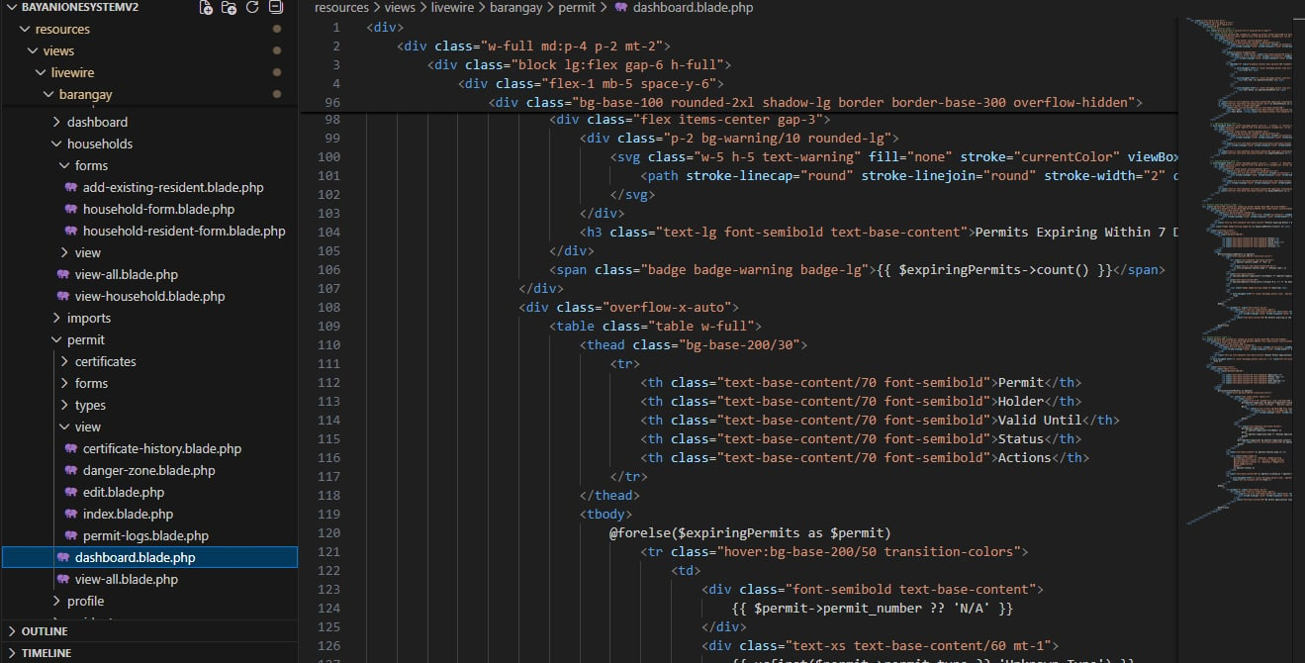

**Figure 33.** HTML & CSS design

Figure 33 shows the UI/UX design code used in the ONESYS web-based front-end development, showcasing the integration of Hypertext Markup Language (HTML) and Cascading Style Sheets (CSS). The HTML code defines the structural layout of key interface components, including navigation menus, user input forms, and information display sections. Meanwhile, the CSS code enhances the visual presentation of these elements by applying styles related to color schemes, typography, spacing, and layout responsiveness. These design components work together to ensure a clean, organized, and user-friendly interface that adapts effectively across different devices.

1. **Laravel, php for programming language**

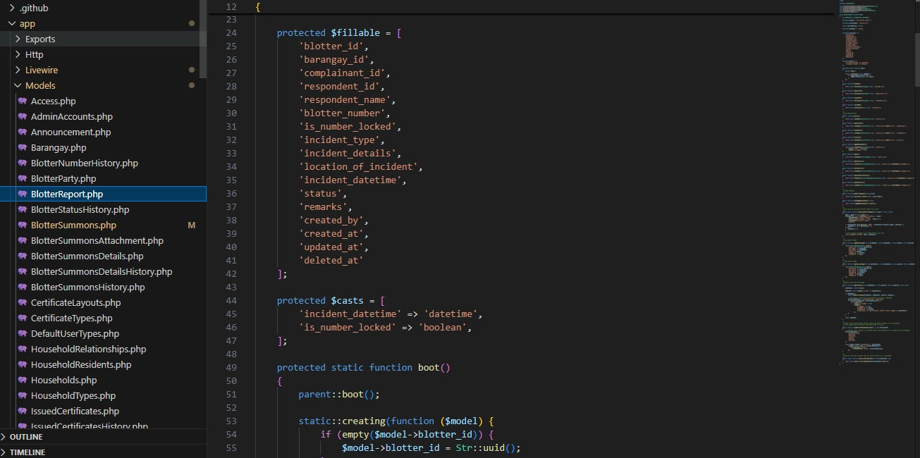**Figure 34.** Laravel

**Figure 35.** php

Figure 34 and 35 shows the backend technologies has been used is Laravel and php. The Laravel provides the efficient environment for managing the routes, controllers, authentication, and data processing. And PHP, as the core server-side scripting language, for logic behind these operations, that enable the dynamic content generation and smooth communication with the database

**d. SQL for Database**

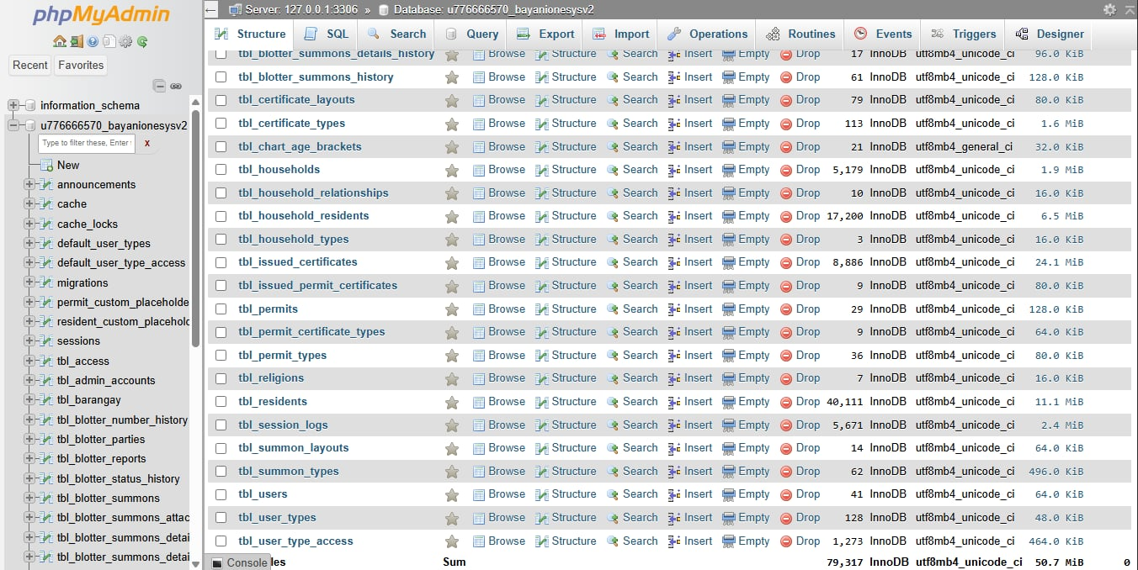

**Figure 36. SQL for Database**

Figure 36 shows that the system used SQL for Database, SQL was used for designing and managing the ONESYS database. It handles the creation of tables, relationships, and queries that store essential information such as resident profiles, blotter reports, business permit applications, and payment transactions. Through SQL queries, the system can efficiently retrieve, update, and organize data, ensuring accuracy and integrity across all records.

**System Testing**

After developing the system in the building phase, the system was tested to functionality, portability, and efficiency testing. The team used the testing results as the foundation for improvement by carefully reviewing each phase. The software testing environments include objects for checking, frequency, and four testers: quality assurance testers, web developer testers, usability testers, and security testers. The percentage is used to determine the percentage of testing based on the tester's evaluation.

**Table 4**. First Testing for Environments of Bayani Onesys: Enhancement and Development of Barangay Management Information System in the Bayani Cluster

|  |  |  |
| --- | --- | --- |
| **ITEMS FOR CHECKING** | **FREQUENCY** | **PERCENT (%)** |
| 1**.**The role of the tester had been clearly defined**.** | 5/6 | 90% |
| 2.The tester used the project in different web browser application |  |  |
| 1. Google Chrome | 10 | 100% |
| b. Microsoft Edge | 10 | 100% |
| c. Mozilla Firefox | 10 | 100% |
| d. Internet explorer | 9 | 90% |
| 3.The tester used the project in the following screen resolution: |  |  |
| a. 1080 x 1920 | 10 | 100% |
| b. 480 x 800 | 10 | 100% |
| c. 720 x 1280 | 9 | 90% |

**N=10 (number of tries / tests)**

Table 4 showed the results of the first software testing regarding the system's usable environments. A total of six (6) testers evaluated the with a (90%) success rate. They test the system using various web browsers such as Google Browser, Microsoft Edge, Mozilla Firefox, and Internet explorer in the first test, all the web browsers had a success rate of (97.5%). The testers also assessed the system using three (3) screen resolutions to evaluate the system: 1080 x 1920, 480 x 800, and 720 x 1280. All the screen resolutions had a (96.67%) success rate.

**Table 5**. Second Testing for Environments of Bayani Onesys: Enhancement and Development of Barangay Management Information System in the Bayani Cluster

|  |  |  |
| --- | --- | --- |
| **ITEMS FOR CHECKING** | **FREQUENCY** | **PERCENT (%)** |
| 1**.**The role of the tester had been clearly defined**.** | 6/6 | 100% |
| 2.The tester used the project in different web browser application |  |  |
| a. Google Chrome | 10 | 100% |
| b. Microsoft Edge | 10 | 100% |
| c. Mozilla Firefox | 10 | 100% |
| d. Internet explorer | 10 | 100% |
| 3.The tester used the project in the following screen resolution: |  |  |
| a. 1080 x 1920 | 10 | 100% |
| b. 480 x 800 | 10 | 100% |
| c. 720 x 1280 | 10 | 100% |

**N=10 (number of tries / tests)**

Table 5 shows the overall result of testing for the software testing environments, after a week of first testing, the second round of testing showed significant improvement, with all testers having a (100%) success rate. The testing for different web browser had a success rate of (100%), and testing for different screen resolution had a success rate of (100%) for the testers' second testing.

**Table 6**. First Functionality testing of Bayani Onesys: Enhancement and Development of Barangay Management Information System in the Bayani Cluster

|  |  |  |
| --- | --- | --- |
| **CRITERIA** | **FREQUENCY** | **PERCENT (%)** |
| **A. Dashboard Module** |  |  |
| 1. Check Issued Certificates | **9** | **90%** |
| 1. Check Resident Count | **9** | **90%** |
| 1. Check Household Count | **9** | **90%** |
| 1. Check User Accounts | **9** | **90%** |
| 1. Check Senior Citizens | **9** | **90%** |
| 1. Check Voters Count | **9** | **90%** |
| 1. Check PWD Count | **9** | **90%** |
| 1. Check 4Ps Beneficiaries Count | **8** | **80%** |
| 1. Check Out-of-School Youth Count | **8** | **80%** |
| 1. Check Top Issued Certificates | **9** | **90%** |
| 1. Check Resident by Age and Sex | **8** | **80%** |
| 1. Check Total Counts of Religion Distribution | **9** | **90%** |
| 1. Check Daily Certificates Receipts | **9** | **90%** |
| **B. View all Residents Module** |  |  |
| 1. The page must consist of the information of residents | **9** | **90%** |
| 1. Check the Search Bar | **8** | **80%** |
| 1. Check the Filter Button | **9** | **90%** |
| 1. Check the Export Button | **9** | **90%** |
| 1. Check the Large Icon (View Photo & Details) | **8** | **80%** |
| 1. Check the Camera Icon | **8** | **80%** |
| 1. Check the Columns Button | **8** | **80%** |
|  |  |  |
| **Table 6.** Continued |  |  |
| **CRITERIA** | **FREQUENCY** | **PERCENT (%)** |
| 1. Verify if the dropdown correctly shows/hides specific columns | **8** | **80%** |
| 1. Check Household | **9** | **90%** |
| 1. Check the Action “View” Button | **9** | **90%** |
| **C. View All Households Module** |  |  |
| 1. Check the Household List Display | **9** | **90%** |
| 1. Check the “Add” Button | **9** | **90%** |
| 1. Check the View Household Button | **9** | **90%** |
| **D. Certificates Types Module** |  |  |
| 1. Check the Certificate Types Display | **9** | **90%** |
| 1. Check the “Create New Certificate” Button | **9** | **90%** |
| 1. Check the View Certificate Details Button | **9** | **90%** |

|  |  |  |
| --- | --- | --- |
| **E.** **Certificate Layouts Module** |  |  |
| 1. Check the Certificate Layouts List | **9** | **90%** |
| 1. Check the “Create Certificate Layout” Button | **9** | **90%** |
| 1. Check the View / Edit Layout Button | **9** | **90%** |
| **F.** **Certificate History Module** |  |  |
| 1. Check Certificates History Display | **9** | **90%** |
| 1. Check the Search Bar (Certificates History) | **9** | **90%** |
| 1. Check Filters for History | **9** | **90%** |
|  |  |  |
|  |  |  |
| **Table 6.** Continued |  |  |
| **CRITERIA** | **FREQUENCY** | **PERCENT (%)** |
| **G. Blotter Module** |  |  |
| 1. Check Blotter Dashboard | **9** | **90%** |
| 1. Check Total Blotters | **9** | **90%** |
| 1. Check Status Filters: | **8** | **80%** |
| 1. Check View Button in Summon Schedule/Blotter reports | **9** | **90%** |
| **H. Blotter Reports Module** |  |  |
| 1. Check Blotter Reports Display | **9** | **90%** |
| 1. Check Report Filters | **9** | **90%** |
| 1. Check Add New Blotter Report Button | **9** | **90%** |
| **I.** **Summon Types Module** |  |  |
| 1. Check All Summon Types | **9** | **90%** |
| 1. Check Create New Summon Type Button | **8** | **80%** |
| **J. Summon Layout Module** |  |  |
| 1. Check Summon Layout Display | **9** | **90%** |
| 1. Check Create New Layout Button | **9** | **90%** |
| 1. Check View Summon Layout | **9** | **90%** |
| **K.** **Permits Module** |  |  |
| 1. Check Permit Dashboard | **9** | **90%** |
| 1. Check Total Permit | **9** | **90%** |
| 1. Check Total Pending Permit | **8** | **80%** |
|  |  |  |
|  |  |  |
| **Table 6.** Continued |  |  |
| **CRITERIA** | **FREQUENCY** | **PERCENT (%)** |
| 1. Check Active Permit | **9** | **90%** |
| 1. Check Rejected Permits | **9** | **90%** |
| 1. Check View Button in Permit Applications | **9** | **90%** |
| **L.** **Permit Applications Module** |  |  |
| 1. Check All Permits Record | **9** | **90%** |
| 1. Check Create New Permit | **9** | **90%** |
| 1. Check View Permit Details | **9** | **90%** |
| **M.** **Permit Certificate Types Module** |  |  |
| 1. Check All Certificates Types of Permits | **9** | **90%** |
| 1. Check Create New Certificate Permit | **9** | **90%** |
| 1. Check View Button Permits Layout | **8** | **80%** |
| **N. Analytics Certificate Module** |  |  |
| 1. Check Analytics and Certificate Records | **9** | **90%** |
| **O. Analytic Residents Module** |  |  |
| 1. Check Residents Analytics | **9** | **90%** |
| 1. Check Total of Male and Female Button if functionable | **8** | **80%** |
| 1. Check Total Religion Distribution | **9** | **90%** |

|  |  |  |
| --- | --- | --- |
| **P.** **Analytic Permits Module** |  |  |
| 1. Check Daily Permits Receipts | **9** | **90%** |
| 1. Check Revenue Summary | **8** | **80%** |
|  |  |  |
|  |  |  |
| **Table 6.** Continued |  |  |
| **CRITERIA** | **FREQUENCY** | **PERCENT (%)** |
| 1. Check Permits Status | **8** | **80%** |
| 1. Check Data Export Button | **9** | **90%** |

|  |  |  |
| --- | --- | --- |
| **Q. User Accounts Module** |  |  |
| 1. Check User Accounts List | **9** | **90%** |
| 1. Check User Account Details | **9** | **90%** |
| **R. User Types Module** |  |  |
| 1. Check User Types List | **9** | **90%** |
| 1. Check Create New User Type | **9** | **90%** |
| **S. Data Module** |  |  |
| 1. Check the Import Data Options | **9** | **90%** |
| 1. Check the File Upload Function | **9** | **90%** |
| 1. Check the Data Mapping | **9** | **90%** |
| 1. Check Successful Import Results | **9** | **90%** |

**N=10 (number of tries / tests)**

Table 5 showed the functionality testing results of the Bayani Onesys system during its first testing by six (6) testers across multiple system modules. On the Dashboard Module which had (87.69%), indicating that the core dashboard indicators performed reliably. The View All Residents Module had (85%), the View All Households Module had (90%), the Certificates Types Module had (90%), Certificate Layouts Module had (90%), Certificate History Module had (90%). the Blotter Module garnered (87.5%), and the Blotter Reports Module had (90%) performance, the Summon Types Module obtained 85%, the Summon Layout Module had (90%). The Permits Module had (88.33%), followed by the Permit Applications Module with (90%) and Permit Certificate Types Module with (86.67%). The Analytics Certificate Module had a (90%) success rate. while t the Analytic Residents Module had (86.67%), the Analytic Permits Module had (85%) functionality, the User Account Module had (90%), the User Type Module had 90% and Data Module had 90% of success rate.

**Table 7**. Second Functionality testing of Bayani Onesys: Enhancement and Development of Barangay Management Information System in the Bayani Cluster

|  |  |  |
| --- | --- | --- |
| **CRITERIA** | **FREQUENCY** | **PERCENT (%)** |
| **A. Dashboard Module** |  |  |
| 1. Check Issued Certificates | **10** | **100%** |
| 1. Check Resident Count | **10** | **100%** |
| 1. Check Household Count | **10** | **100%** |
| 1. Check User Accounts | **10** | **100%** |
| 1. Check Senior Citizens | **10** | **100%** |
| 1. Check Voters Count | **10** | **100%** |
| 1. Check PWD Count | **10** | **100%** |
| 1. Check 4Ps Beneficiaries Count | **10** | **100%** |
| 1. Check Out-of-School Youth Count | **10** | **100%** |
| 1. Check Top Issued Certificates | **10** | **100%** |
| 1. Check Resident by Age and Sex | **10** | **100%** |
| 1. Check Total Counts of Religion Distribution | **10** | **100%** |
| 1. Check Daily Certificates Receipts | **10** | **100%** |
| **B. View all Residents Module** |  |  |
| 1. The page must consist of the information of residents | **10** | **100%** |
| 1. Check the Search Bar | **10** | **100%** |
|  |  |  |
|  |  |  |

|  |  |  |
| --- | --- | --- |
| **Table 7.** Continued |  |  |
| **CRITERIA** | **FREQUENCY** | **PERCENT (%)** |
| 1. Verify if the dropdown correctly shows/hides specific columns | **10** | **100%** |
| 1. Check the Filter Button | **10** | **100%** |
| 1. Check the Export Button | **10** | **100%** |
| 1. Check the Large Icon (View Photo & Details) | **10** | **100%** |
| 1. Check the Camera Icon | **10** | **100%** |
| 1. Check the Columns Button | **10** | **100%** |
| 1. Check Household | **10** | **100%** |
| 1. Check the Action “View” Button | **10** | **100%** |
| **C. View All Households Module** |  |  |
| 1. Check the Household List Display | **10** | **100%** |
| 1. Check the “Add” Button | **10** | **100%** |
| 1. Check the View Household Button | **10** | **100%** |
| **D. Certificates Types Module** |  |  |
| 1. Check the Certificate Types Display | **10** | **100%** |
| 1. Check the “Create New Certificate” Button | **10** | **100%** |
| 1. Check the View Certificate Details Button | **10** | **100%** |
| **E. Certificate Layouts Module** |  |  |
| 1. Check the Certificate Layouts List | **10** | **100%** |
| 1. Check the “Create Certificate Layout” Button | **10** | **100%** |

|  |  |  |
| --- | --- | --- |
| **Table 7.** Continued |  |  |
| **CRITERIA** | **FREQUENCY** | **PERCENT (%)** |
| 1. Check the View / Edit Layout Button | **10** | **100%** |
| **F. Certificate History Module** |  |  |
| 1. Check Certificates History Display | **10** | **100%** |
| 1. Check the Search Bar (Certificates History) | **10** | **100%** |
| 1. Check Filters for History | **10** | **100%** |
| **G. Blotter Module** |  |  |
| 1. Check Blotter Dashboard | **10** | **100%** |
| 1. Check Total Blotters | **10** | **100%** |
| 1. Check Status Filters: | **10** | **100%** |
| 1. Check View Button in Summon Schedule/Blotter reports | **10** | **100%** |
| **H. Blotter Reports Module** |  |  |
| 1. Check Blotter Reports Display | **10** | **100%** |
| 1. Check Report Filters | **10** | **100%** |
| 1. Check Add New Blotter Report Button | **10** | **100%** |
| **I. Summon Types Module** |  |  |
| 1. Check All Summon Types | **10** | **100%** |
| 1. Check Create New Summon Type Button | **10** | **100%** |
| **J. Summon Layout Module** |  |  |
| 1. Check Summon Layout Display | **10** | **100%** |
| 1. Check Create New Layout Button | **10** | **100%** |
| 1. Check View Summon Layout | **10** | **100%** |
|  |  |  |

|  |  |  |
| --- | --- | --- |
| **Table 7.** Continued |  |  |
| **CRITERIA** | **FREQUENCY** | **PERCENT (%)** |
| **K. Permits Module** |  |  |
| 1. Check Permit Dashboard | **10** | **100%** |
| 1. Check Total Permit | **10** | **100%** |
| 1. Check Total Pending Permit | **10** | **100%** |
| 1. Check Active Permit | **10** | **100%** |
| 1. Check Rejected Permits | **10** | **100%** |
| 1. Check View Button in Permit Applications | **10** | **100%** |
| **L. Permit Applications Module** |  |  |
| 1. Check All Permits Record | **10** | **100%** |
| 1. Check Create New Permit | **10** | **100%** |
| 1. Check View Permit Details | **10** | **100%** |
| **M. Permit Certificate Types Module** |  |  |
| 1. Check All Certificates Types of Permits | **10** | **100%** |
| 1. Check Create New Certificate Permit | **10** | **100%** |
| 1. Check View Button Permits Layout | **10** | **100%** |
| **N. Analytics Certificate Module** |  |  |
| 1. Check Analytics and Certificate Records | **10** | **100%** |
| **O. Analytic Residents Module** |  |  |
| 1. Check Residents Analytics | **10** | **100%** |
| 1. Check Total of Male and Female Button if functionable | **10** | **100%** |
| 1. Check Total Religion Distribution | **10** | **100%** |
|  |  |  |

|  |  |  |  |
| --- | --- | --- | --- |
| **Table 7.** Continued | |  |  |
| **CRITERIA** | | **FREQUENCY** | **PERCENT (%)** |
| **P. Analytic Permits Module** |  |  |
| 1. Check Daily Permits Receipts | **10** | **100%** |
| 1. Check Revenue Summary | **10** | **100%** |
| 1. Check Permits Status | **10** | **100%** |
| 1. Check Data Export Button | **10** | **100%** |
| **Q. User Accounts Module** | |  |  |
| 1. Check User Accounts List | | **10** | **100%** |
| 1. Check User Account Details | | **10** | **100%** |
| **R. User Types Module** | |  |  |
| 1. Check User Types List | | **10** | **100%** |
| 1. Check Create New User Type | | **10** | **100%** |
| **S. Data Module** | |  |  | |
| 1. Check the Import Data Options | | **10** | **100%** | |
| 1. Check the File Upload Function | | **10** | **100%** | |
| 1. Check the Data Mapping | | **10** | **100%** | |
| 1. Check Successful Import Results | | **10** | **100%** | |

**N=10 (number of tries / tests)**

Table 7 showed the functionality testing results of the Bayani Onesys web-based system on the second testing by the six (6) testers across multiple system modules. On the Dashboard Module which had (100%), indicating that the core dashboard indicators performed reliably. The View All Residents Module had (100%), the View All Households Module had (100%), the Certificates Types Module had (100%), Certificate Layouts Module had (100%), Certificate History Module had (100%). the Blotter Module garnered (100%), and the Blotter Reports Module had (100%) performance, the Summon Types Module obtained 100%, the Summon Layout Module had (100%). The Permits Module had (100%), followed by the Permit Applications Module with (100%) and Permit Certificate Types Module with (100%). The Analytics Certificate Module had a (100%) success rate. while t the Analytic Residents Module had (100%), the Analytic Permits Module had (100%) functionality, the User Account Module had (100%), the User Type Module had 90% and Data Module had (100%) of success rate.

**Table 8**. Overall Results of the Functionality Testing of Bayani Onesys: Enhancement and Development of Barangay Management Information System in the Bayani Cluster

|  |  |
| --- | --- |
| **CRITERIA** | **RESULTS OF TESTING** |
| 1. **Dashboard Module** | PASSED |
| 1. **View all Residents Module** | PASSED |
| 1. **View All Households Module** | PASSED |
| 1. **Certificates Types Module** | PASSED |
| 1. **Certificate Layouts Module** | PASSED |
| 1. **Certificate History Module** | PASSED |
| 1. **Blotter Module** | PASSED |
| 1. **Blotter Reports Module** | PASSED |
| 1. **Summon Types Module** | PASSED |
| 1. **Summon Layout Module** | PASSED |
| 1. **Permits Module** | PASSED |
| 1. **Permit Applications Module** | PASSED |
| 1. **Permit Certificate Types Module** | PASSED |
| 1. **Analytics Certificate Module** | PASSED |
| 1. **Analytic Residents Module** | PASSED |
| 1. **Analytic Permits Module** | PASSED |
| 1. **User Accounts Module** | PASSED |
| 1. **User Types Module** | PASSED |
| 1. **Data Module** | PASSED |

Table 8 displayed the overall functionality testing results of the Bayani Onesys web-based system on the second testing by the six (6) testers across multiple system modules. On the Dashboard Module, View All Residents Module, View All Households Module, Certificates Types Module, Certificate Layouts Module, Certificate History Module, Blotter Module, Blotter Reports Module, the Summon Types Module, the Summon Layout Module, Permits Module, Permit Applications Module, Permit Certificate Types Module, Analytics Certificate Module, Analytic Residents Module, the Analytic Permits Module, User Account Module, User Type Module and Data Module that passed the functionality test.

**Table 9**. Portability Testing for Bayani Onesys: Enhancement and Development of Barangay Management Information System in the Bayani Cluster

|  |  |  |  |
| --- | --- | --- | --- |
| **BROWSER** | **WORKED PROPERLY** | **ACTION** | **RESPONSE TIME (S)** |
| Google Chrome | 100% | Dashboard Module | 2s |
| Microsoft Edge | 100% | View all Household Module | 2s |
| Mozilla Firefox | 100% | Blotter Report Module | 2s |
| Internet Explorer | 100% | Permit Application module | 5s |

Table 9 shows the overall portability testing results wherein all the Bayani Onesys modules were tested on different browsers. In terms of Dashboard, it was tested on Google Chrome with a success rate of (100%) with a 2-second response, the View all Household module was tested on Microsoft Edge with a success rate of (100%) with a 2-second response, the Blotter Report module module was tested on Mozilla Firefox with a success rate of (100%) with a 2-second response, and Permit Application module was tested on the Internet Explorer with a (100%) success rate with a 5-second response,

**System Evaluation**

The performance of the system was evaluated based on ISO 25010. There

were forty (40) respondents is presented in the tables below such as the end users and IT Experts. The developed system was evaluated in terms of Functional Suitability (Table 10), Performance Efficiency (Table 11), Compatibility (Table 12), Usability (Table 13), Reliability (Table 14), Security (Table 15), Maintainability (Table 16), and Portability (Table 17).

**Table 10**. Functional Suitability of Bayani Onesys: Enhancement and Development of Barangay Management Information System in the Bayani Cluster

|  |  |  |  |
| --- | --- | --- | --- |
| **INDICATOR** | **MEAN** | **STANDARD DEVIATION** | **VERBAL INTERPRETATION** |
| Functional Completeness | 4.68 | 0.52563 | Highly Acceptable |
| Functional Correctness | 4.63 | 0.54006 | Highly Acceptable |
| Functional Appropriateness | 4.50 | 0.55238 | Highly Acceptable |
| **COMPOSITE SCORE** | 4.62 | 0.53740 | Highly Acceptable |

Table 10 showed shows the evaluation of the respondents on the Bayani Onesys web-based system based on Functional Suitability. It was explicitly determined by its Completeness, Correctness, and Appropriateness. The composite obtained with a weighted mean of 4.62 with an SD= 0.53740, respectively, having a verbal interpretation of Highly Acceptable Highly Acceptable. The highest score is Functional Completeness had a weighted mean of 4.68 with an SD= 0.52563 with a verbal interpretation of Highly Acceptable. Functional Correctness got a weighted mean of 4.63 with an SD= 0.54006 and a verbal interpretation of Highly Acceptable, while the lowest is Functional Appropriateness had a weighted mean of 4.50 with an SD=0.55238, with a verbal interpretation of Highly Acceptable. According to the respondents, the Bayani Onesys web-based system could be effective in functional suitability. This means that the Bayani Onesys meets the required standards for ISO 25010 for functionality.

A study titled, "Enhancement of Barangay Management System," published in the Global Scientific Journal (2024), highlighted the importance of a user-friendly interface in barangay management systems. The enhanced system featured a dashboard presenting relevant data and metrics in a graphical format, allowing authorized users to easily understand the current status, trends, and performance of various aspects of barangay management. This design aimed to improve the efficiency, transparency, and accountability of barangay operations.

**Table 11.** Performances Efficiency of Bayani Onesys: Enhancement and Developme nt of Barangay Management Information System in the Bayani Cluster

|  |  |  |  |
| --- | --- | --- | --- |
| **INDICATOR** | **MEAN** | **STANDARD DEVIATION** | **VERBAL INTERPRETATION** |
| Time Behavior | 4.53 | 0.64001 | Highly Acceptable |
| Resource Utilization | 4.48 | 0.67889 | Acceptable |
| Capacity | 4.53 | 0.59861 | Highly Acceptable |
| **COMPOSITE SCORE** | 4.51 | 0.63505 | Highly Acceptable |

Table 11 showed the evaluation of the respondents on the Bayani Onesys system based on Performance Efficiency, which was determined by three criteria: Time Behavior, Resource Utilization, and Capacity. Time Behavior. The composite obtained a weighted mean of 4.51 with SD=0.63505 with a verbal interpretation of Highly Acceptable. The highest score are Time Behavior and Capacity obtained a weighted mean of 4.53 with SD=0.64001 with SD=0.59861 with a verbal interpretation of Highly Acceptable and the lowest score had a weighted mean of 4.48 with SD=0.67889 with a verbal interpretation of Acceptable. This showed that the Bayani Onesys web-based system meets the required standards for ISO 25010 and could be effective in terms of performance efficiency.

The research supports that the efficiency performance results of Table 11 is the “BALANGAY: Web-Based Barangay Management System” (2022), which was evaluated using the ISO 9126 quality model. The study of Bautista et al. (2023) findings showed high ratings related to the performance factors, particularly in system responsiveness and its processing time during different barangay transactions. In this study emphasized that a barangay system must operate quickly and efficient, wherein delays should not happen, specifically during peak service hours when multiple requests are being processed.

**Table 12**. Compatibility of Bayani Onesys: Enhancement and Development of Barangay Management Information System in the Bayani Cluster

|  |  |  |  |
| --- | --- | --- | --- |
| **INDICATOR** | **MEAN** | **STANDARD**  **DEVIATION** | **VERBAL**  **INTERPRETATION** |
| Co-existence | 4.50 | 0.64051 | Highly Acceptable |
| Interoperability | 4.60 | 0.59052 | Highly Acceptable |
| **COMPOSITE SCORE** | 4.55 | 0.61418 | Highly Acceptable |

Table 12 showed the respondents' evaluation of the Bayani Onesys web-based system based on Compatibility and its Co-existence and Interoperability were determined. The composite score obtained a weighted mean of 4.55 with a SD=0.61418 a verbal interpretation of Highly Acceptable. The highest score was Interoperability obtained a weighted mean of 4.60 with SD=0.59052 with a verbal interpretation of Highly Acceptable. Co-existence obtained a weighted mean of 4.50 with SD=0.64051a verbal interpretation of Highly Acceptable. This showed that the Bayani Onesys web-based system could provide effectivity regarding Compatibility.

A study titled "Development and Evaluation of a Web-Based Resident Information Management System" emphasizes the importance of compatibility in barangay systems. It highlights that adaptability to different devices and operating systems is vital for successful implementation and user satisfaction. Ensuring compatibility enhances accessibility and usability, allowing barangay officials and residents to interact with the system without technical hindrances (Melendes et al, 2023).

**Table 13**. Usability of Bayani Onesys: Enhancement and Development of Barangay Management Information System in the Bayani Cluster

|  |  |  |  |
| --- | --- | --- | --- |
| **INDICATOR** | **MEAN** | **STANDARD DEVIATION** | **VERBAL INTERPRETATION** |
| Appropriateness recognizability | 4.55 | 0.71432 | Highly Acceptable |
| Learnability | 4.55 | 0.59700 | Highly Acceptable |
| Operability | 4.68 | 0.57233 | Highly Acceptable |
| User error - protection | 4.48 | 0.75064 | Acceptable |
| User interface aesthetics | 4.50 | 0.67937 | Highly Acceptable |
| Accessibility | 4.65 | 0.57957 | Highly Acceptable |
| **COMPOSITE SCORE** | 4.57 | 0.64986 | Highly Acceptable |

Table 13 showed the respondents' evaluation of the Bayani Onesys web-based system based on Usability. It was determined by six criteria: Appropriateness, Recognizability, Learnability, Operability, User Error Protection, User Interface Aesthetics, and Accessibility. The composite obtained a weighted mean of 4.57 with SD=0.64986 with a verbal interpretation of Highly Acceptable. The highest score is Operability obtained a weighted mean of 4.68 with SD=0.57233 with a verbal interpretation of Highly Acceptable. Accessibility obtained a weighted mean of 4.65 with a SD=0.57957 with a verbal interpretation of Highly Acceptable. For Appropriateness recognizability obtained a weighted mean of 4.55 with a SD=0.71432 with a verbal interpretation of Highly Acceptable, For Learnability obtained a weighted mean of 4.55 with SD=0.59700 with a verbal interpretation of Highly Acceptable. User Interface Aesthetics obtained a weighted mean of 4.50 with SD=0.67937 with a verbal interpretation of Highly Acceptable. The lowest score is User error – protection obtained a weighted mean of 4.48 with SD=0.75064 with a verbal interpretation of Acceptance. This showed that the Bayani Onesys web-based system could be effective in usability.

A study titled "E-Barangay: A Framework for a Web-Based System for Local Communities and Its Usability" developed a web-based system based on the e-barangay framework and evaluated its usability. Thematic analysis of interviews with local officials identified core elements such as filing complaints, requesting documents, sending suggestions, and posting announcements. Both objective and subjective measures of usability showed favorable results, indicating that the software satisfied the needs of the stakeholders (Bringula et al. 2022).

**Table 14**. Reliability of Bayani Onesys: Enhancement and Development of Barangay Management Information System in the Bayani Cluster

|  |  |  |  |
| --- | --- | --- | --- |
| **INDICATOR** | **MEAN** | **STANDARD DEVIATION** | **VERBAL INTERPRETATION** |
| Maturity | 4.55 | 0.71432 | Highly Acceptable |
| Availability | 4.60 | 0.54538 | Highly Acceptable |
| Fault - tolerance | 4.55 | 0.67748 | Highly Acceptable |
| Recoverability | 4.48 | 0.71567 | Acceptable |
| **COMPOSITE SCORE** | 4.54 | 0.662062 | Highly Acceptable |

Table 14 showed the respondents' evaluation of the Bayani Onesys web-based system based on Reliability, explicitly determined by its Maturity, Availability, Fault Tolerance, and Recoverability. The composite obtained a weighted mean of 4.54 with SD=0.662062 with a verbal interpretation of Highly Acceptable. The highest score is Availability had a weighted mean of 4.60 with SD=0.54538, with a verbal interpretation of Highly Acceptable. Maturity got a weighted mean of 4.55 with SD=0.71432 with a verbal interpretation of Highly Acceptable. Fault Tolerance had a weighted mean of 4.55 with SD=0.67748 with a verbal interpretation of Highly Acceptable. The lowest score is Recoverability, it had a weighted mean of 4.48 with SD=0.71567, with a verbal interpretation of Acceptable. This showed that, according to the respondents, the Bayani Onesys web-based system was effective in terms of Reliability.

A study titled "Barangay Management System" emphasizes the importance of reliability in system performance. The research highlights that the system should work reliably, incorporating automatic backup and recovery features to prevent data loss and ensure continuous availability, except during scheduled maintenance or unforeseen internet connectivity issues. This reliability is crucial for maintaining uninterrupted access to services for both officials and residents (Carpio 2020).

**Table 15**. Security of Bayani Onesys: Enhancement and Development of Barangay Management Information System in the Bayani Cluster

|  |  |  |  |
| --- | --- | --- | --- |
| **INDICATOR** | **MEAN** | **STANDARD DEVIATION** | **VERBAL INTERPRETATION** |
| Confidentiality | 4.48 | 0.81610 | Acceptable |
| Integrity | 4.50 | 0.75107 | Highly Acceptable |
| Non - repudiation | 4.50 | 0.71611 | Highly Acceptable |
| Accountability | 4.48 | 0.71567 | Acceptable |
| Authenticity | 4.55 | 0.63851 | Highly Acceptable |
| **COMPOSITE SCORE** | 4.50 | 0.72292 | Highly Acceptable |

Table 15 shows the evaluation of the respondents on Bayani Onesys web-based system based on Security and is determined specifically by its Confidentiality, Integrity, Non-repudiation, Accountability, and Authenticity. The composite obtained a weighted mean of 4.50 with SD=0.72292 with a verbal interpretation of Highly Acceptable. The highest score is Authenticity has a weighted mean of 4.55 with SD=0.63851 with a verbal interpretation of Highly Acceptable. Non- repudiation got a weighted mean of 4.50 with SD=0.71611 with a verbal interpretation of Highly Acceptable. Integrity also has a weighted mean of 4.50 with SD=0.75107 with a verbal interpretation of Acceptable. The lowest score is Accountability, it has a weighted mean of 4.48 with SD=0.71567, with a verbal interpretation of Acceptable and Confidentiality has a weighted mean of 4.48 with SD=0.81610 with a verbal interpretation of Acceptable. This shows that according to the respondents, the system was able to provide effectivity in terms of Security.

Security is a critical aspect of any record management system because it ensures the confidentiality, integrity, and availability of data, Data protection laws, such as the Data Privacy Act of 2012 (Republic Act No. 10173) in the Philippines, emphasize the need for robust security measures in managing personal information. A failure to comply can lead to legal penalties and damage to institutional credibility. Researchers like Solove (2013) in Privacy and Big Data underline the importance of integrating security protocols to meet these legal requirements.

**Table 16**. Maintainability of Bayani Onesys: Enhancement and Development of Barangay Management Information System in the Bayani Cluster

|  |  |  |  |
| --- | --- | --- | --- |
| **INDICATOR** | **MEAN** | **STANDARD DEVIATION** | **VERBAL INTERPRETATION** |
| Modularity | 4.48 | 0.67889 | Acceptable |
| Reusability | 4.45 | 0.71432 | Acceptable |
| Analyzability | 4.53 | 0.64001 | Highly Acceptable |
| Modifiability | 4.50 | 0.67937 | Highly Acceptable |
| Testability | 4.55 | 0.67748 | Highly Acceptable |
| **COMPOSITE SCORE** | 4.50 | 0.67250 | Highly Acceptable |

Table 16 presented the respondents' evaluation of the Bayani Onesys web-based system based on maintainability, which was determined by five criteria: Modularity, Reusability, Analyzability, Modifiability, and Testability. The composite obtained a weighted mean of 4.50 with SD=0.67250 with a verbal interpretation of Highly Acceptable. The highest score is Testability obtained a weighted mean of 4.55 with SD=0.67250 with a verbal interpretation of Highly Acceptable. Modifiability obtained a weighted mean of 4.50 with SD=0.67937 with a verbal interpretation of Highly Acceptable. Analyzability had a weighted mean of 4.53 with SD=0.64001, with a verbal interpretation of Highly Acceptable. The lowest score are Modularity had a weighted mean of 4.48 with SD=0.67889, with a verbal interpretation of Acceptable and The lowest score is Reusability obtained a weighted mean of 4.45 with SD=0.71432 with a verbal interpretation of Acceptable. This showed that the Bayani Onesys web-based system was effective in maintainability.

This study emphasizes the importance of designing barangay management systems with high maintainability to facilitate efficient updates and modifications. The research highlights the development of a "Household" module that allows barangay officials to manage household information effectively, supporting informed decision-making. The system's design ensures that updates and maintenance can be performed with minimal disruption to services (Maribao, 2024).

**Table 17**. Portability of Bayani Onesys: Enhancement and Development of Barangay Management Information System in the Bayani Cluster

|  |  |  |  |
| --- | --- | --- | --- |
| **INDICATOR** | **MEAN** | **STANDARD DEVIATION** | **VERBAL INTERPRETATION** |
| Adaptability | 4.54 | 0.63630 | Highly Acceptable |
| Installability | 4.54 | 0.6745 | Highly Acceptable |
| Replaceability | 4.51 | 0.71141 | Highly Acceptable |
| **COMPOSITE SCORE** | 4.53 | 0.66929 | Highly Acceptable |

Table 17 showed the respondents' evaluation of the Bayani Onesys web-based system based on portability, which was determined by three criteria: Adaptability, Installability, and Replicability. The composite score obtained a weighted mean of 4.53 with SD=0.66929 with a verbal interpretation of Highly Acceptable. The highest score is Adaptability obtained a weighted mean of 4.54 with 0.63630 with a verbal interpretation of Acceptable and Installability obtained a weighted mean of 4.54 with SD=0.6745 with a verbal interpretation of Acceptable. The lowest score Replaceability had a weighted mean of 4.51 with SD=0.71141 with a verbal interpretation of Acceptable. This showed that the system could be effective in terms of portability. The study was conducted to implement a comprehensive management system for the barangay that serves the officials and the citizens. Specifically, it aimed to provide the features starting from its simple transactions such as posting news and announcements, presenting barangay projects and achievements, promoting business and other commercial establishments within the barangay, up to its complex service of managing barangay citizen’s complaints, providing barangay certifications and other necessary transactions forms efficiently, and a comprehensive view of the barangay transactions and services through a dashboard that displays its transaction logs and reports (senaris, 2023).

**Table 18.** Overall evaluation result of Bayani Onesys: Enhancement and Development of Barangay Management Information System in the Bayani Cluster

|  |  |  |  |
| --- | --- | --- | --- |
| **INDICATOR** | **MEAN** | **STANDARD DEVIATION** | **VERBAL INTERPRETATION** |
| Functional Suitability | 4.62 | 0.53740 | Highly Acceptable |
| Performances Efficiency | 4.51 | 0.63505 | Highly Acceptable |
| Compatibility | 4.55 | 0.61418 | Highly Acceptable |
| Usability | 4.57 | 0.64986 | Highly Acceptable |
| Reliability | 4.54 | 0.66206 | Highly Acceptable |
| Security | 4.50 | 0.72292 | Highly Acceptable |
| Maintainability | 4.50 | 0.67250 | Highly Acceptable |
| Portability | 4.53 | 0.66929 | Highly Acceptable |
| **OVERALL COMPOSITE SCORE** | **4.54** | **0.05393** | **Highly Acceptable** |

Table 18 showed the overall general weighted mean of the respondent's evaluation of the counseling system per criteria. Based on the criteria, the overall composite score is weighted mean of the respondents was 4.54 with SD=0.05393, with a verbal interpretation of Highly Acceptable. This means the Bayani Onesys web-based system meet the required standards of ISO 25010 Functional Suitability, Performance Efficiency, Compatibility, Usability, Reliability, Security, Maintainability, and Portability. Thus, the high ratings confirm that the Bayani Onesys aligns with these standards and it is highly acceptable for its end users.

**SUMMARY, CONCLUSION AND RECOMMENADATIONS**

The obtained data generated the following findings:

1. The design of the enhancement and development of barangay management information system in the bayani cluster

The ONESYS: Enhancement and Development of the Barangay Management Information System in the Bayani Cluster was designed using Figma for wireframes and interface layouts and Visual Studio Code as an Integrated Development Environment or (IDE) for building and managing the system’s code. The web-based design integrated modern development tools and frameworks to support the platform to be more user-friendly and responsive platform. The system contains the features that the researchers created to help the users meet the satisfaction they needed while using the system.

2. The development of the enhancement and development of barangay management information system in the bayani cluster

The development of the onesys web-based system was guided by an Agile model because this approach enabled the team to continuously gather feedback and then implement the improvements at each stage. The system was created using Visual Studio Code serving as the main development environment, and Bootstrap for creating a responsive and user-friendly interface that would adapt responsively to different devices and screen sizes. The core functionalities were implemented using PHP with the Laravel framework, and SQL was used to handle the database, ensuring accurate storage and efficient retrieval of records.

3. The testing of the enhancement and development of barangay management information system in the bayani cluster

The system underwent for unit testing, integration and system testing to ensure that it is performed efficiently, functional and it was cross-platform compatible. All browsers and screen resolutions used by the testers had a 100% success rate, showing that the system is performing consistently and reliably. The results verified that the system is stable and fully operational, and each module was functioning as expected throughout the testing phase.

4. The evaluate system using the ISO evaluation instrument

The assessed acceptance functionality of the developed web-based system was evaluated using the Core App Quality by a total of 30 potential users and 10 IT Experts.  
The overall mean of the web-based system Bayani Onesys obtained a composite mean score is 4.54with SD=0.05393which indicates that the system is well prepared, fully functional and very useful and had possessed an excellent performance and the ability to satisfy the user. These results shows that ONESYS possesses excellent performance, meets the needs of its users, and provides a reliable platform for managing resident records, processing documents, and enhancing service delivery across the Bayani Cluster.

5. Prepare an implementation plan

The Bayani onesys system was successfully hosted on World Wide Web using Hostinger, the process took approximately five hours to complete. After hosting complete, the system was implemented in nine (9) barangays in the Bayani cluster.

The barangay captain authorized the implementation of the system through an official permission letter. System materials were distributed during a barangay session meeting, which took at least one full day to complete and secretary underwent two days of instruction and hands-on training to ensure that they fully understand the system.

**Conclusion**

As the local government units (LGU's), particularly the barangays are expected to catch up with the increasing population and growing demands for faster and more reliable public services. In respond to these issues, the enhanced and implementation of Bayani Onesys successfully address the critical challenges faced by barangays in Bayani Cluster in managing community records, the enhancement and development of Bayani Onesys help the barangays to manage records more effectively, streamline their daily operations, and deliver services with more accurate and speed up processes. Aligned with the study's objective, the system offers a secure and efficient platform to replace outdated manual processes.

The overall result of extensive testing on functionality, portability and efficiency from the evaluators under visual design and user interaction, functionality, compatibility, performance, stability and security confirmed that the system meets a High-quality standards. Feedback from quality assurance testers, usability testers, web developers, and security testers facilitated continuous improvements throughout development.

ONESYS is implement and enhanced specifically for the Bayani Cluster barangays. However, local government units (LGUs) may have their own barangay systems indented for wider user across multiple communities. Even though Onesys has shown that it works effectively and meet the standard based on evaluation, the LGU's possibly may later enforce or mandate all barangays to used their system instead. Despite this possibility, Through the bayani onesys system, barangay officials can easily monitor their resident records and barangay transactions, it allowed them to manage barangay operations more efficiently and give faster processes to the community. As a result, the system not only speeds up the overall barangay operations but also strengthens the delivery of public services by giving residents faster, more accurate, and more reliable services. Ultimately, the system supports a more streamlined, responsive, and modern approach to barangay governance.

**Recommendation**

1. Integrate an AI-powered face recognition feature to allow the system to automatically identify individuals from short video clips or images and match them with existing resident profiles. This enhancement would streamline identity verification and significantly reduce manual searching within the database.
2. Implement an automated document scanning and layout adaptation module capable of reading uploaded PDF or DOCX files and converting them into the barangay’s standardized certificate format. This one-tap layout generation would minimize manual formatting and ensure consistency across all issued documents.
3. Develop full mobile application support to provide users with a portable and accessible version of the Barangay Management Information System, enabling residents and staff to perform essential tasks anytime and anywhere.
4. Introduce a valid ID issuance feature that allows barangay personnel to generate and print official Barangay IDs directly from the system. This addition enhances service convenience and centralizes resident records and identification processes.
5. Explore additional smart automation tools and modules, such as digital signature integration, automated reminders for expiring certificates or IDs, and improved API support for interoperability with LGU or national-level systems. These improvements would future-proof the platform and expand its capabilities to meet the evolving needs of barangay operations.

**RESULTS OF THE INTERVIEW**

## BLOTTER REPORTS

Q16. The most frequently reported timeframe for receiving blotter reports is weekly, accounting for 48.7%.

Q17. The most common incident reported in barangay blotters is theft or robbery, accounting for 30.9%.

Q18. Blotter reports are mostly recorded manually (paper-based logbooks), accounting for 74.4%.

Q19. The Peace and Order Committee is most commonly responsible for handling and recording blotter reports, with 22.8%.

Q20. The most common record retention period is 1–3 years, reported by 38.5% of respondents.

Q21. Blotter reports are most commonly available but require approval from

barangay officials, accounting for 53.8%.

Q22. The most cited challenge in managing blotter reports is limited digital recording systems, mentioned by 40.0%.

Q23. The most frequent coordination with law enforcement is regularly (e.g., monthly meetings), accounting for a combined 77.0%.

Q24. The most suggested improvement is addressing privacy and security concerns, with 44.4% support.

## BUSINESS PERMITS

Q25. 100% of respondents indicated their barangay has a standard process for issuing business permits.

Q26. The most common requirement for obtaining a business permit is a completed application form, reported by 35.3%.

Q27. The average processing time for a business permit is 1–3 days, reported by

100% of respondents.

Q28. The most common type of business applying for permits is sari-sari stores, accounting for 17.3%.

Q29.In processing business permits, Incomplete requirements from applicants is the common challenge barangay encounter accounting for 61.3% of the responses. Q30.The barangay does not offer an online digital application system for business permits, as 100% of the respondents indicated that only in-person applications are accepted.

Q31.The barangay informs business owners about permit renewals and deadlines through direct communication, as indicated by 68.6% of the respondents. Q32. The barangay only conducts inspections to ensure compliance with business regulations when there are complaints, accounting for 54.3% of the responses. Q33. The barangay plans to improve its business permit application process by implementing online registration of DTI, as indicated by 50% of the respondents.

## FEES COLLECTED

Q34.The barangay collects various fees, with barangay clearance fees being the most commonly collected, as indicated by 100% of the respondents.

Q35. The residents and business owners pay their fees through cash payment at the barangay hall, accounting for 100% of the responses.

Q36. The barangay issues official receipts for certain payments, as indicated by 63.2% of the respondents.

Q37. The payment fees and schedules are clearly posted in the barangay hall or online, accounting for 94.9% of the responses.

Q38. Limited payment methods are the most common challenge residents face when making payments in the barangay, as indicated by 71.4% of the respondents. Q39. Manual written records are used by the barangay as the record-keeping system for all payment transactions, as reported by 84.6% of the respondents.

Q40.The barangay can improve its payment process by implementing online payment and other digital payment options.

# REFERENCES

Bautista, M. T. T., Villoria, M. A., Bautista, J. L., & Espino, G. L. (2023). *BALANGAY: A web-based document request and incident reporting system with decision support for barangay program development. In A. K. Nagar, D. Singh Jat, D. K. Mishra, & A. Joshi (Eds.), Intelligent sustainable systems (Vol. 579).* Springer. <https://doi.org/10.1007/978-981-19-7663-6_13>

Bonghanoy, J. M., Mahinay, A. L., & Caballes, J. T. (2021). *E-Barangay: A framework for a web-based system for local communities and its usability.* ResearchGate. <https://www.researchgate.net/publication/357334023>

Bondoc, M., Salazar, M., Martinez, R., & Cruz, A. (2022). *Towards digitization through e-Barangay: A web-based barangay information system.* ResearchGate. <https://www.researchgate.net/publication/359140517>

Dela Cerna, M. A. (2023). *Development and implementation of an office automation system for barangay local government units. 2023 4th International Conference for Emerging Technology (INCET),1–9.*

<https://doi.org/10.1109/INCET57972.2023.10170650>

Dela Cerna, M. A., Sabijon, A. M., & Cagalawan, C. P. (2023). *Development and implementation of an office automation system for barangay local government units.*

ResearchGate. <https://www.researchgate.net/publication/372259322>

Debbarma, R. (2023). *Digital transformation in local governance: Opportunities, Challenges and strategies.*

ResearchGate. <https://www.researchgate.net/publication/376892350>

Del Pilar, C. G. E., Nale, S. G. R., Jinio, A. L., Abando, D. S., Blanco, M. C. R., & Sison, A. A. R. C. (2024). *B-GIS: Modernizing local governance through a web-based barangay geographic information system for Barangay 99, Tondo, Manila. 2024 International Conference on Intelligent Cybernetics Technology & Applications (ICICyTA), 161–166.* <https://doi.org/10.1109/ICICYTA64807.2024.10912845>

Gallera, A. B., & Salvador, J. P. (2023). *Assessment of digital information systems for local barangays. International Research Journal of Advanced Engineering and Science, 8(2),712–719.*

<https://irjaes.com/wp-content/uploads/2023/04/IRJAESV8N2P171Y23.pdf>

Huerta Jr., F. L. (2025). *Data-driven barangay services recommendation system using a recurrent neural network (RNN) algorithm. International Journal of Computing Sciences Research,9,3566–3576.*

<https://www.stepacademic.net/ijcsr/article/view/587>

Imus, J. K. P., Magleo, E. D., Soriano, M. A. A., & Olalia, R. L. (2018). *Barangay management information system (BMIS) for cities and municipalities in the Philippines. International Journal of Computer Applications, 180(19),33-36.* <https://doi.org/10.5120/ijca2018916441>

*Jamis, M. N., Alvior, M., Ramos, L., & Yalong, E. (2022). One Barangay: A mobile and web barangay management system. 2022 2nd International Conference in Information and Computing Research (iCORE),202-207.* <https://doi.org/10.1109/iCORE58172.2022.00055>

Libadia, M., Botangen, K. A., Lucero, P. J., & Tecson, J. (2025). *Development of a web-based records management system: An ERMS initiative for the Office of Senior Citizen Affairs in the Philippines. Records Management Journal, 35(2), 160–179.* <https://doi.org/10.1108/RMJ-06-2023-0031>

Turok, I., & Scheba, A. (2020). *Grassroots democracy and development: Learning from the Philippines.*

ResearchGate. <https://www.researchgate.net/publication/340533162>

Dela Cruz, L. A., Capuno, M., Reyes, J. M., & Bonifacio, R. (2023). *Enhanced barangay information management system with residency certificate issuance. 2023 IEEE 8th International Conference on Recent Advances and Innovations in Engineering (ICRAIE), 1–7.*

<https://doi.org/10.1109/ICRAIE59459.2023.10468134>

Baltazar, V. J., Lagman, A., De Angel, R., & Piad, K. (2020). *Disaster and crime reporting and monitoring system for Hagonoy Bulacan with decision support mechanism.* SSRN. <https://papers.ssrn.com/sol3/papers.cfm?abstract_id=3642023>

*Barangay Blotter and Clearance System of Sta. Maria, Gonzaga, Cagayan, Philippines. (n.d.).* Journal of Public Administration Studies.

<https://csu.org.ph/jpas/article/view/23>

*Development and evaluation of a technology-based barangay management system. (2025). International Journal of Science and Research (IJSR), 14(3).* <https://www.ijsr.net/archive/v14i3/SR25303115701.pdf>

*Design and implementation of a hybrid barangay information management system. (2021).* ResearchGate. <https://www.researchgate.net/publication/351985199>

*Development of an information-based dashboard: Automation of barangay information profiling system (BIPS) for decision support towards e-governance. (2020).* ResearchGate. <https://www.researchgate.net/publication/346794234>

*Information management system with project monitoring for barangay. (2023).* University of Saint Louis Journal. <http://urdc.usl.edu.ph/journals/jeai/papers/vol3/vol%203%20series%202023-51-60.pdf>

*Information system strategic plan (ISSP) for Barangay Bulakin I of Dolores, Quezon, for 2025-2027. (2025).* ResearchGate. <https://www.researchgate.net/publication/382143120>

*Barangay constituents’ information and services management system. (2021).* Academia.edu. <https://www.academia.edu/download/66310481/V10I4202108.pdf>

*Enhancing the barangay information system by integrating geolocation technology and Tagalog chatbot using NLP algorithm for efficient community engagement and service. (2025).* ResearchGate. <https://www.researchgate.net/publication/380069999>

*Establishment of a barangay database information system in Region 10. (n.d.).*

Google Scholar. <https://scholar.google.com>